[1]. Download Python : 3.7.1

[www.python.org](http://www.python.org)

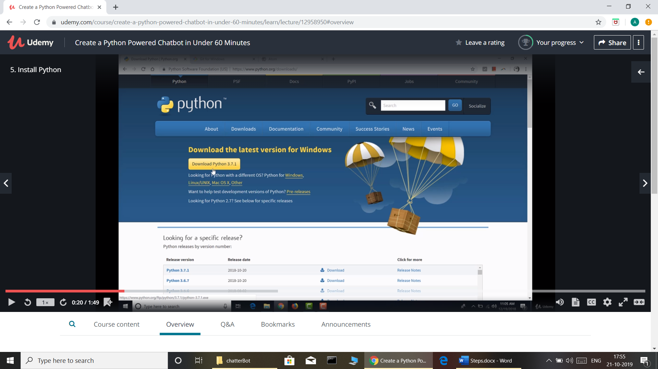

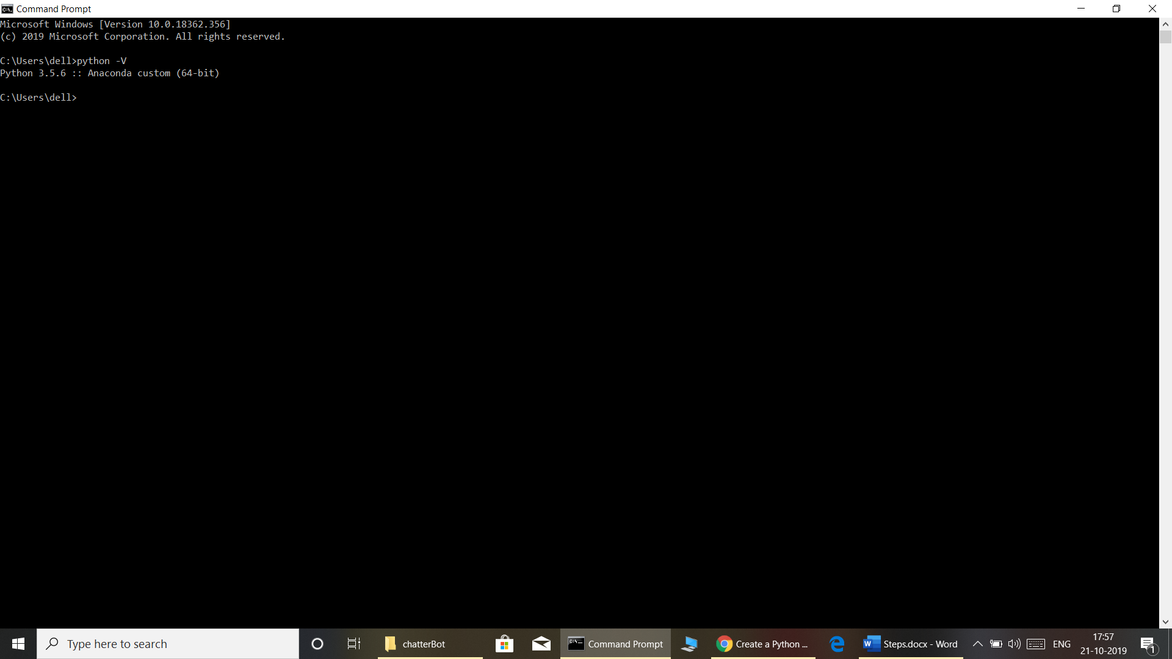

[2] : <https://gitforwindows.org>

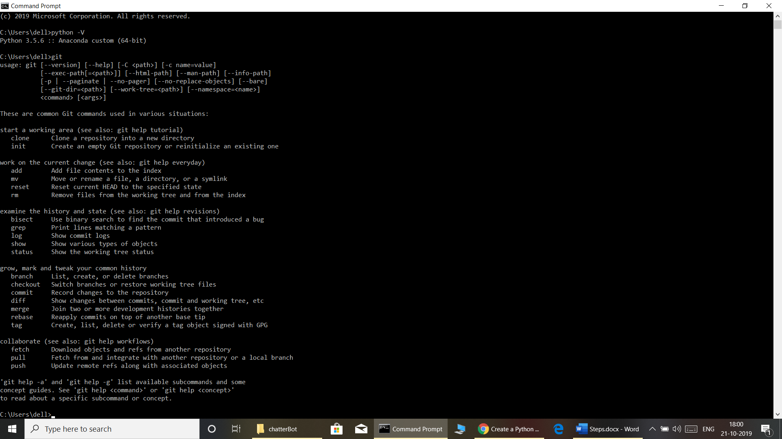

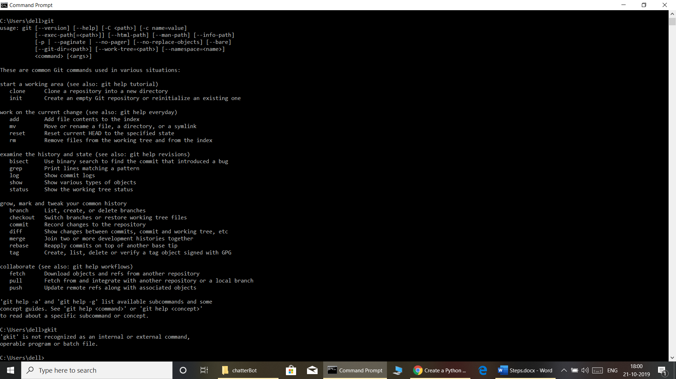

[3] Installing Atom :-

<https://atom.io>

A hackable Text Editor of 21 Centuray.

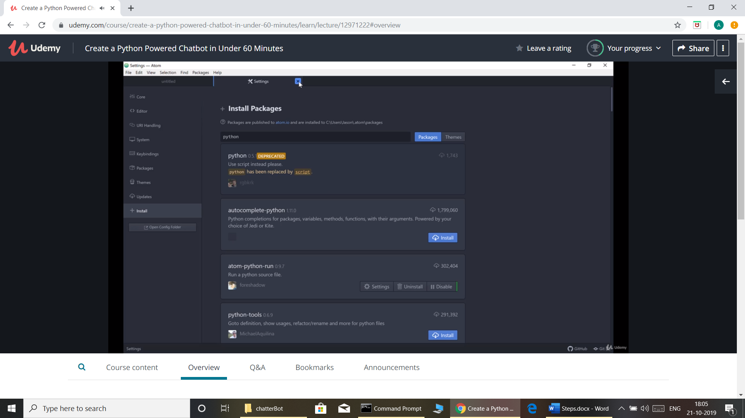

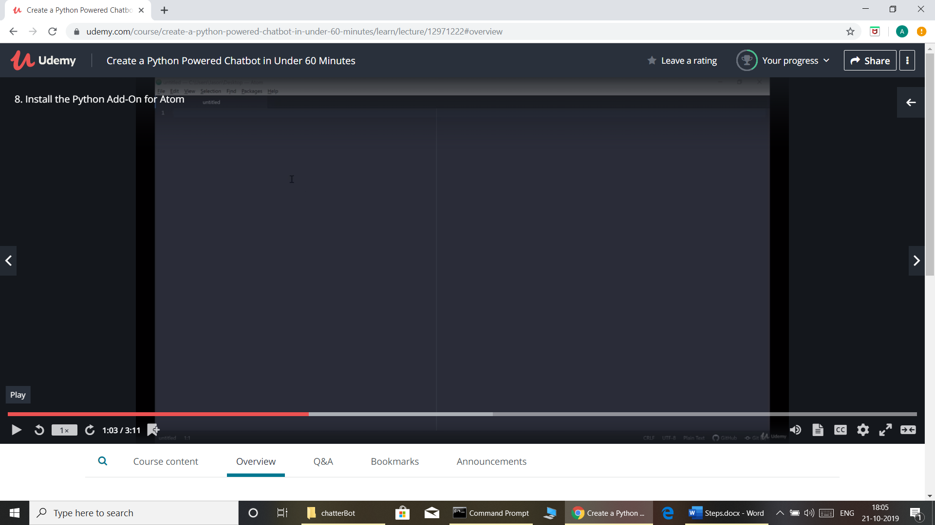

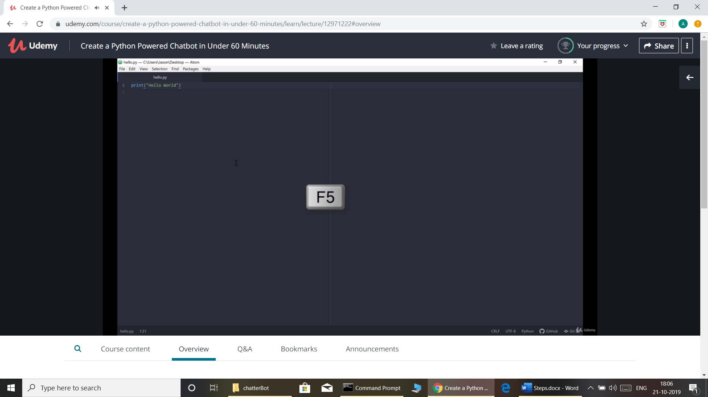

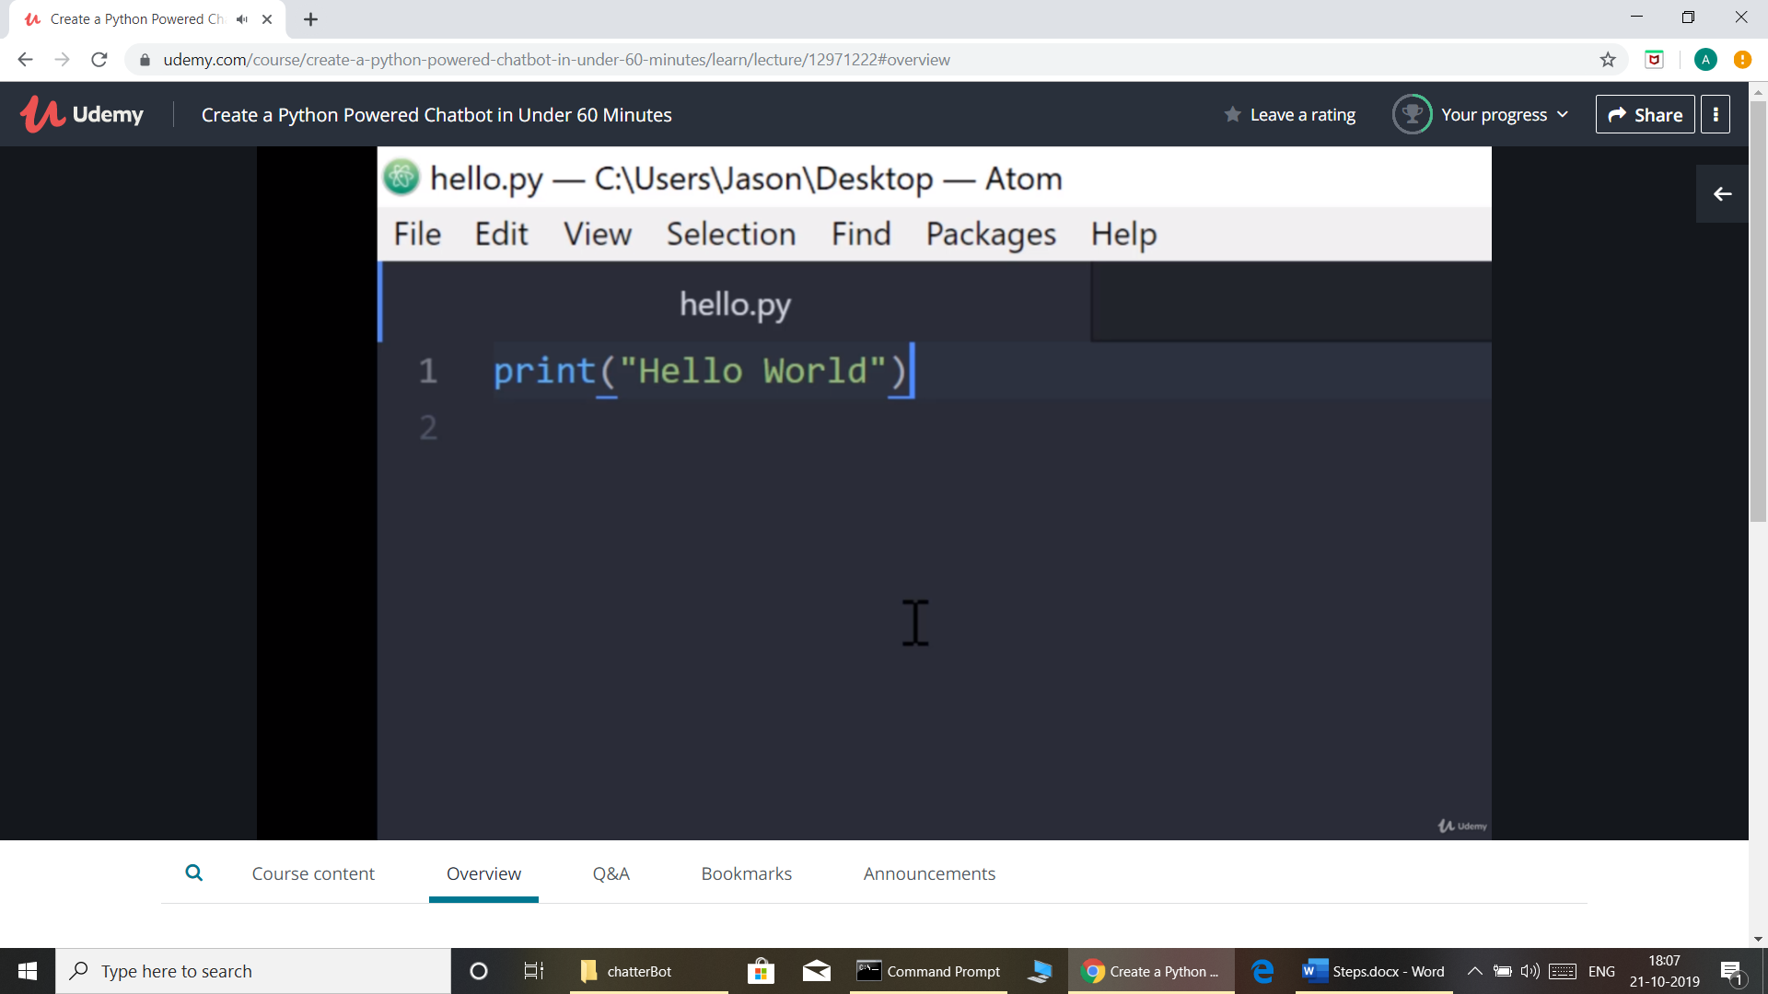

[4] :

D:\UHG-Optum\chatterBot\src>git clone <https://github.com/jkries/mybot.git>

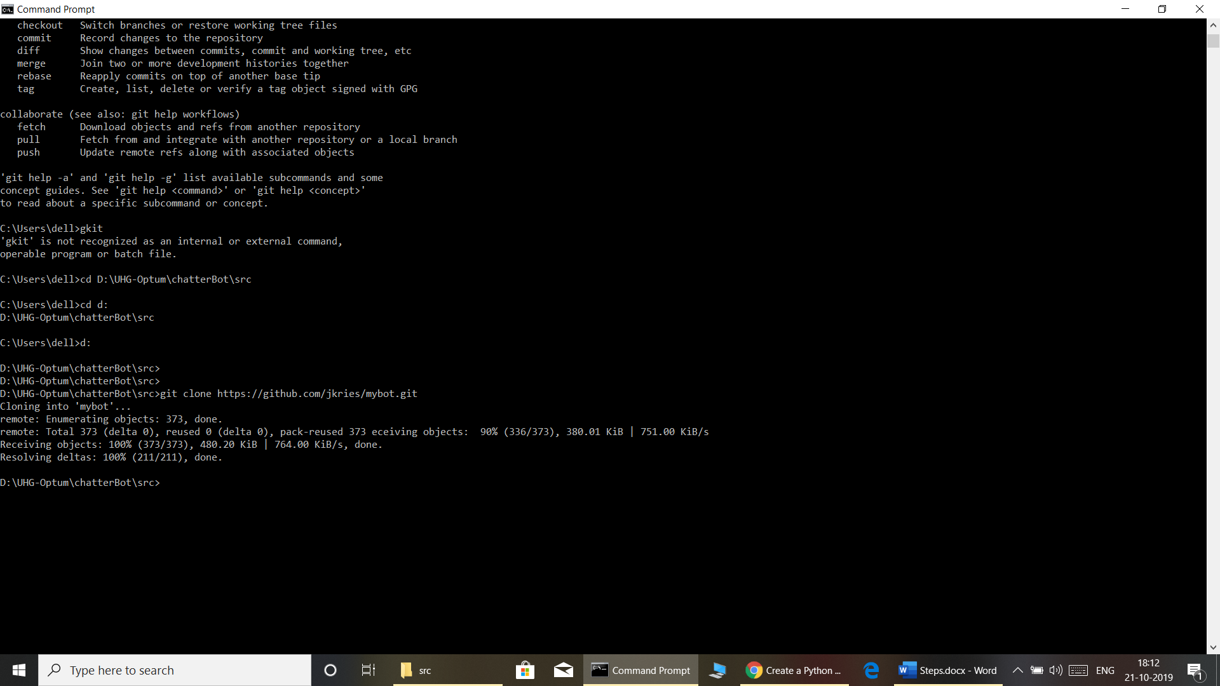

[5]: pip (Python installation packages)

D:\UHG-Optum\chatterBot\src\mybot>pip install -r requirements.txt

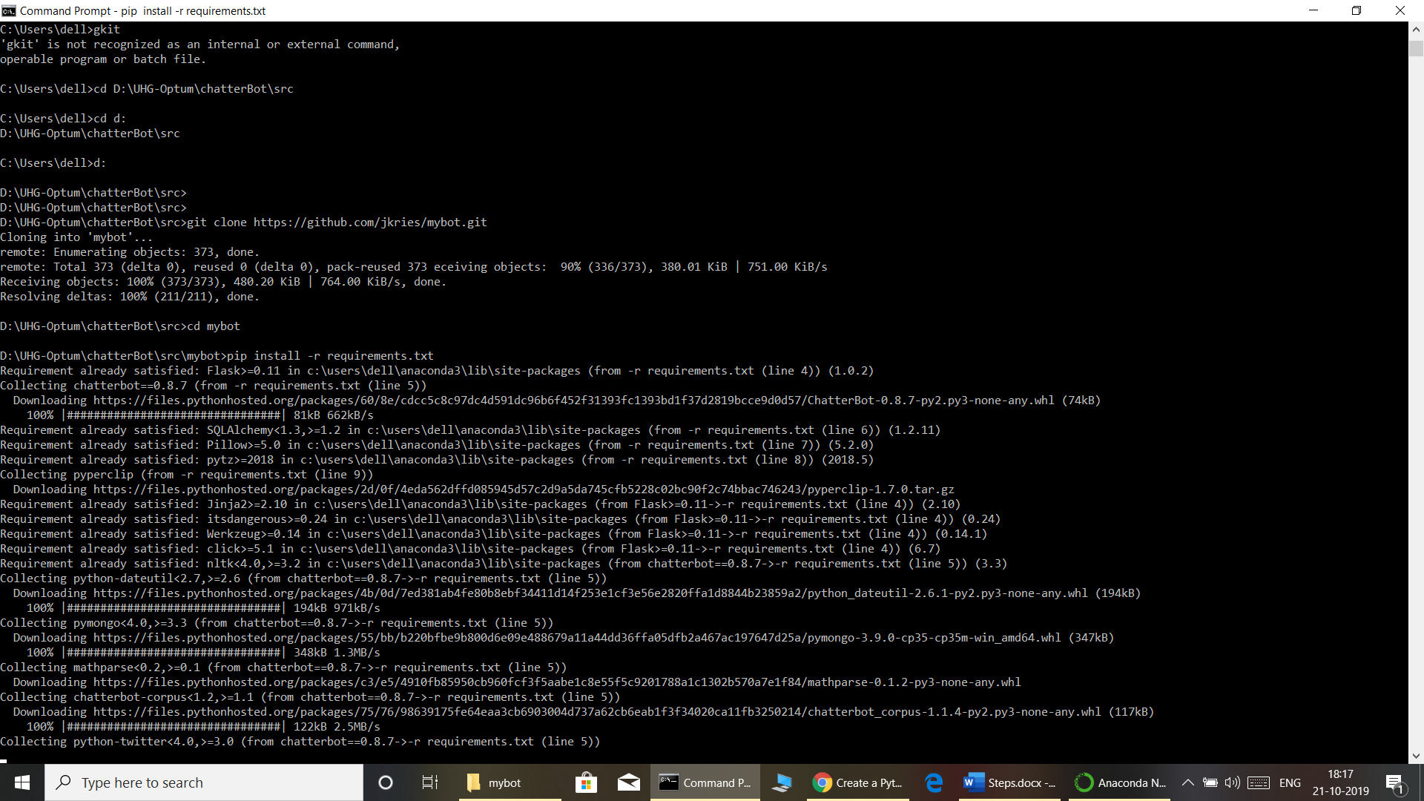

[6]: Run Demo :-

D:\UHG-Optum\chatterBot\src\mybot>python demo.py

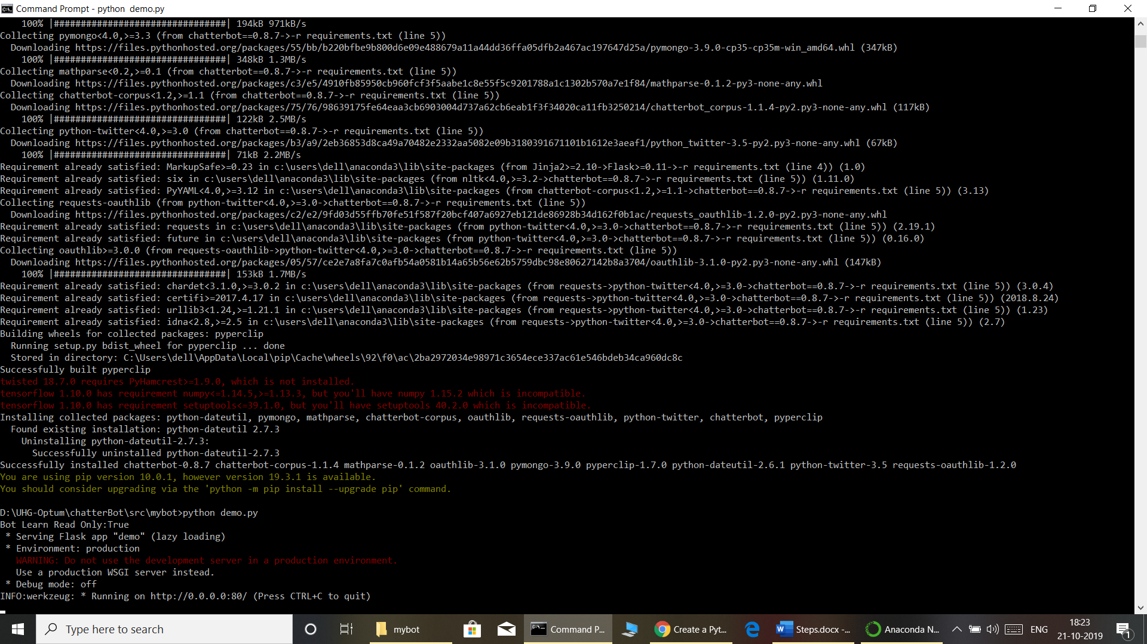

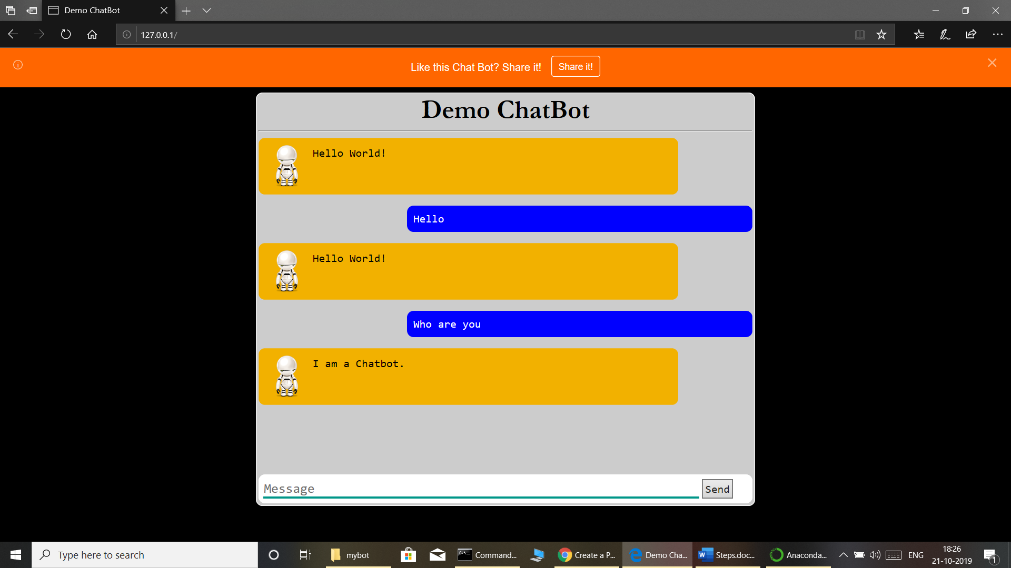

[7]:

<https://docs.google.com/spreadsheets/d/1g-yUqAYzZzXg-98NO-1qVm_n_SoJe82E5s-NFG9Gv9E/edit#gid=0>

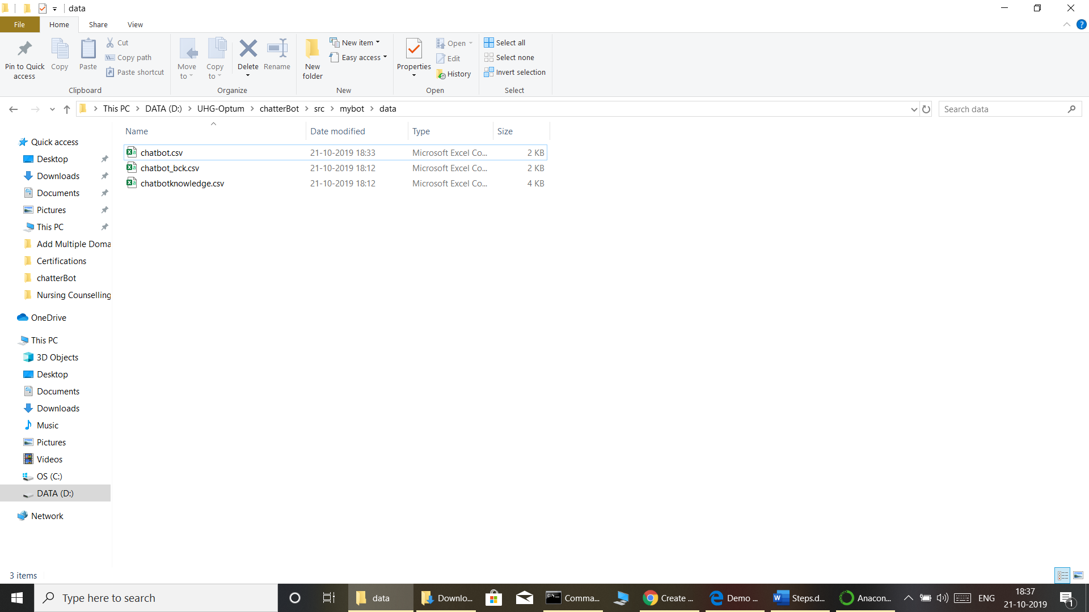

[8]. Training for bot.

D:\UHG-Optum\chatterBot\src\mybot>python train.py

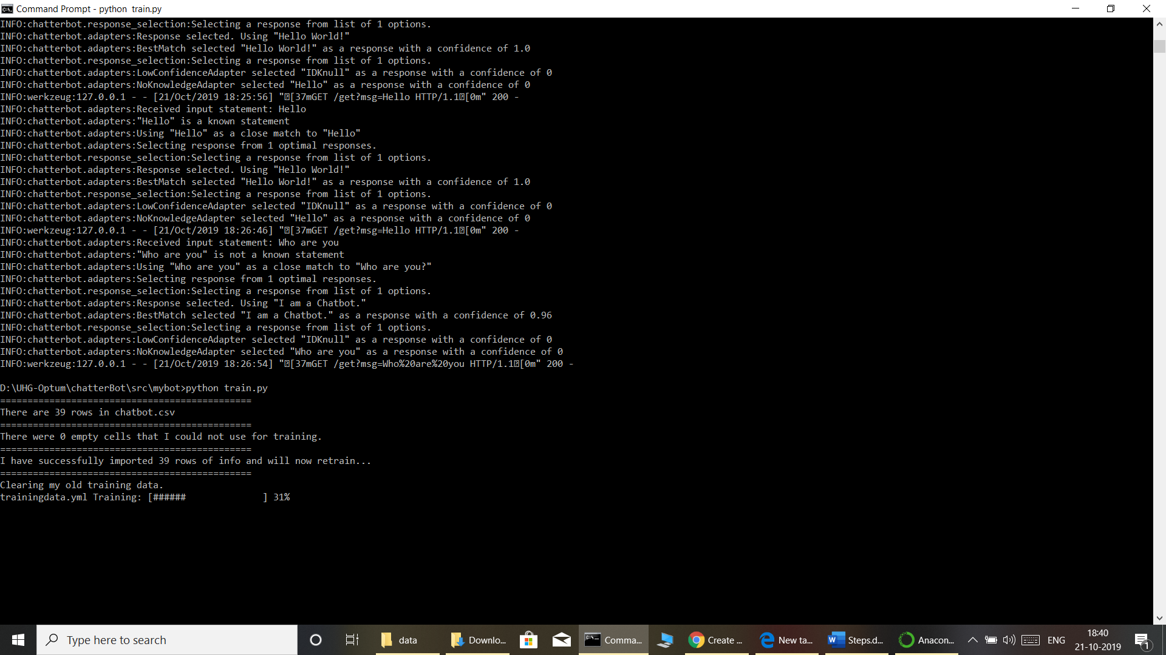

[9 ]: - Chatting after Training

D:\UHG-Optum\chatterBot\src\mybot>python chat.py

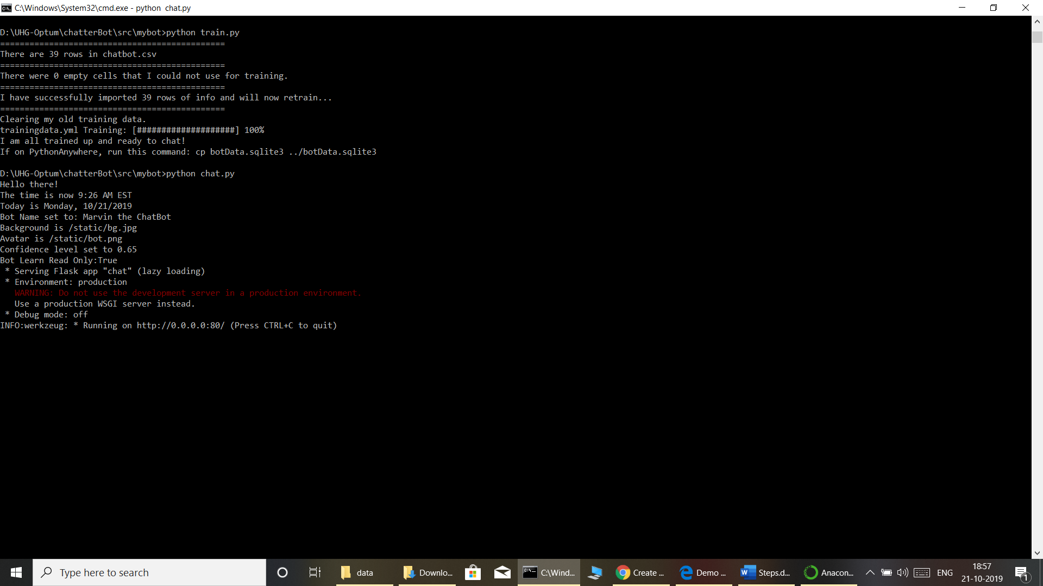

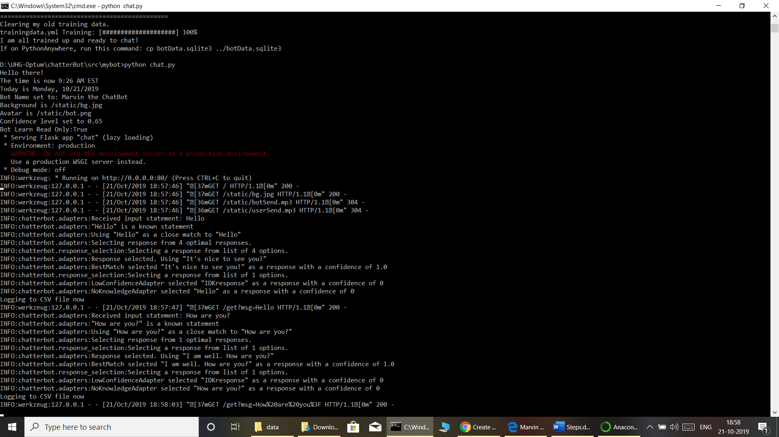

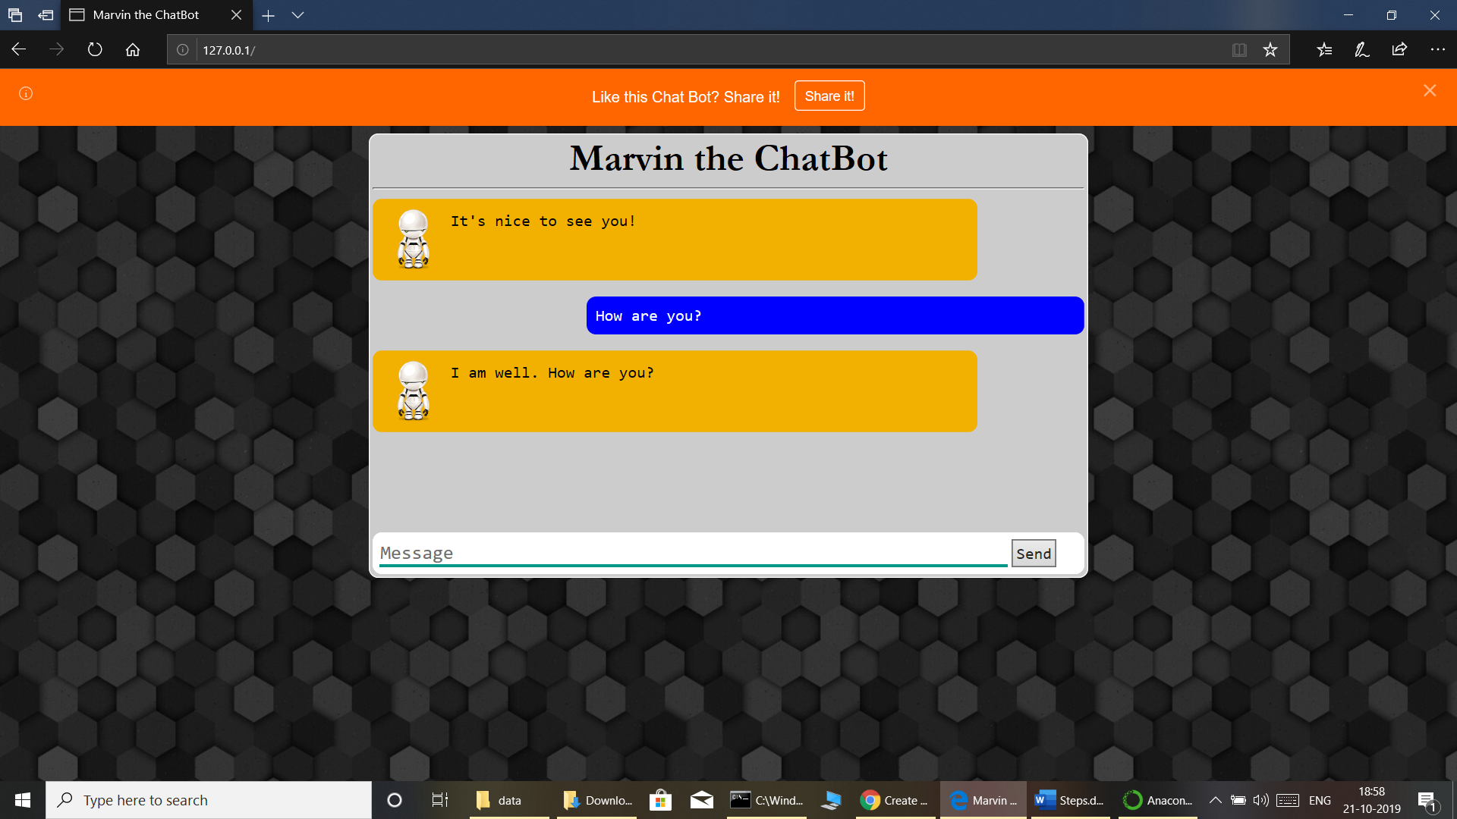

[10]: Customize bot ‘botConfig.py’

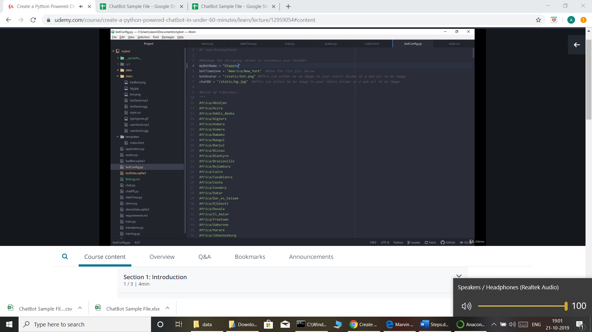

Changing bot icon and background.  
  
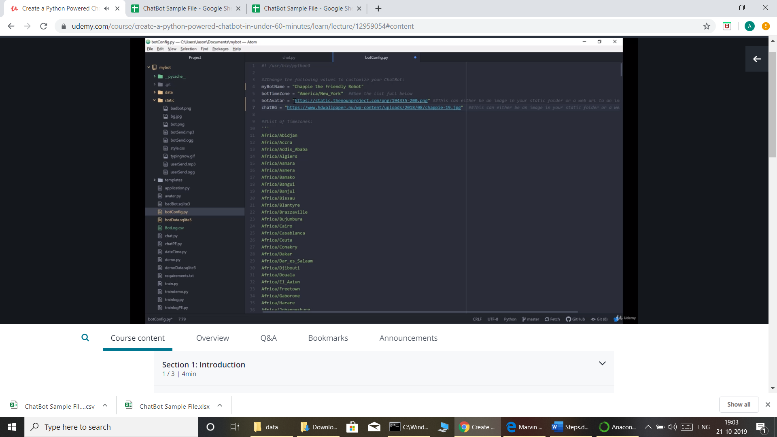

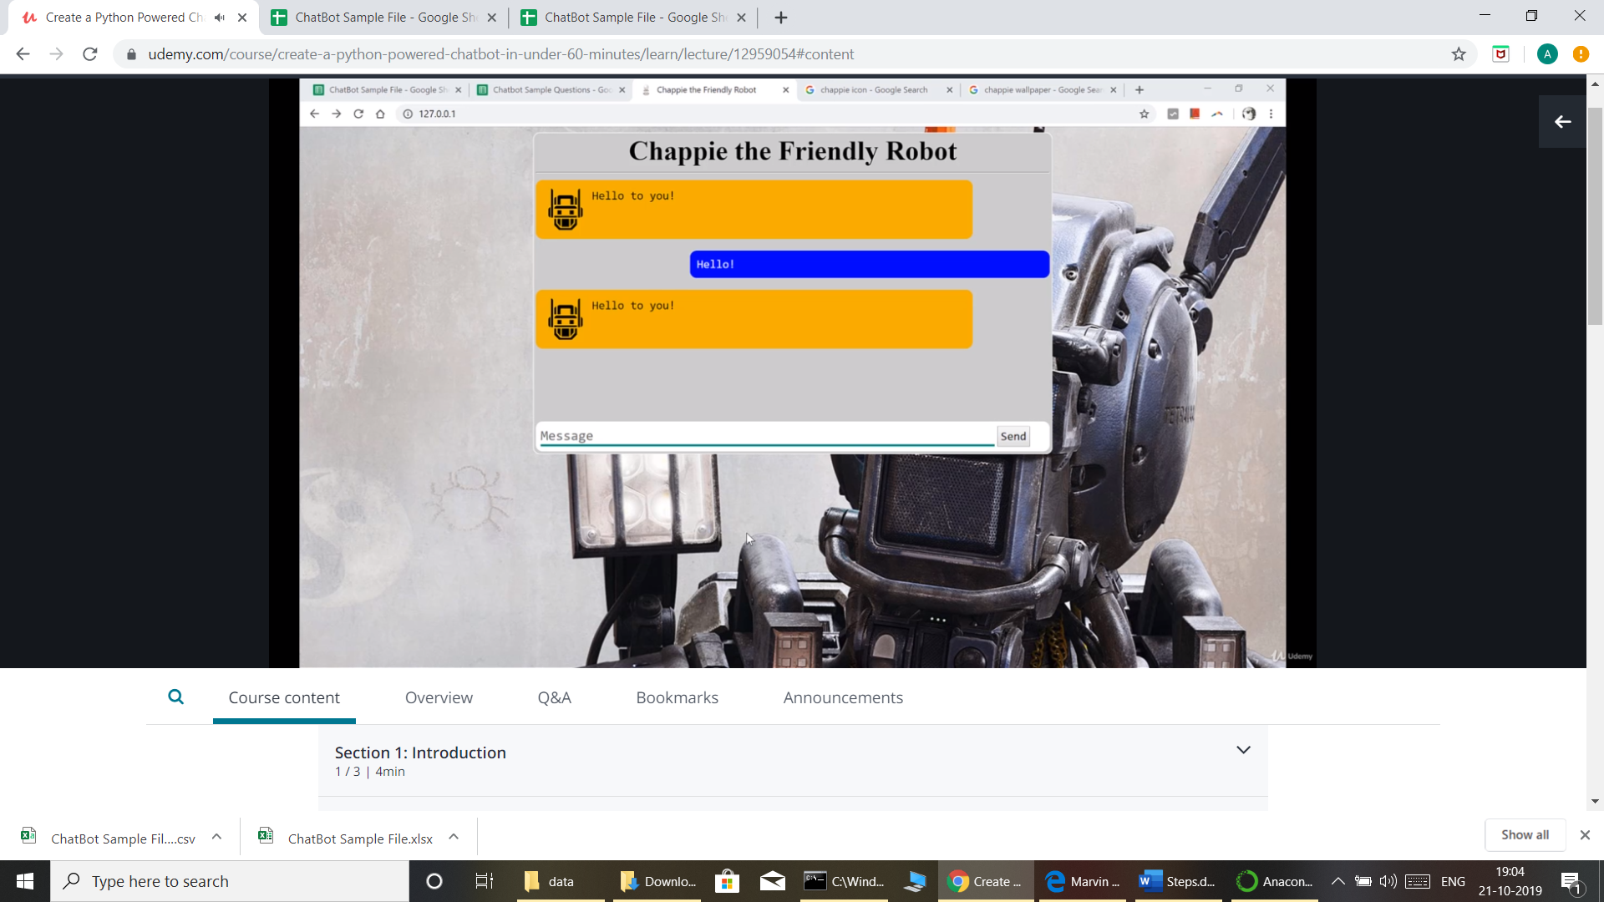

[11]:- Confidence level to understand the asked question .

Using ‘botConfig.py’

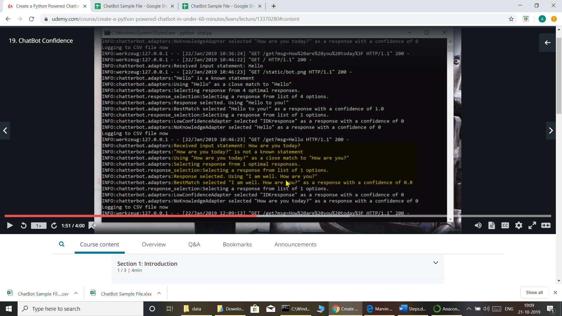

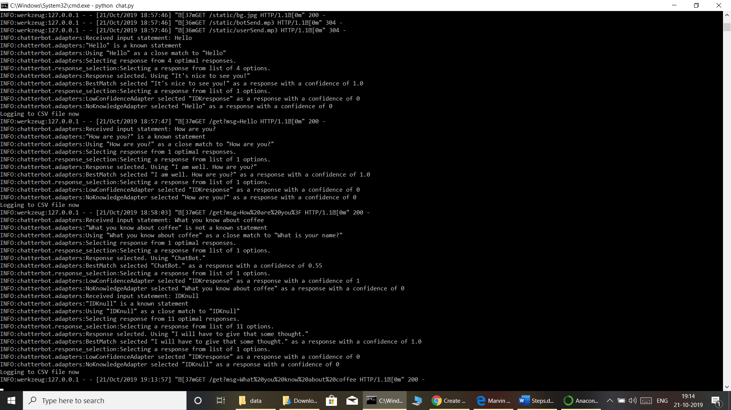

[12] :Setting Random responses for same question.

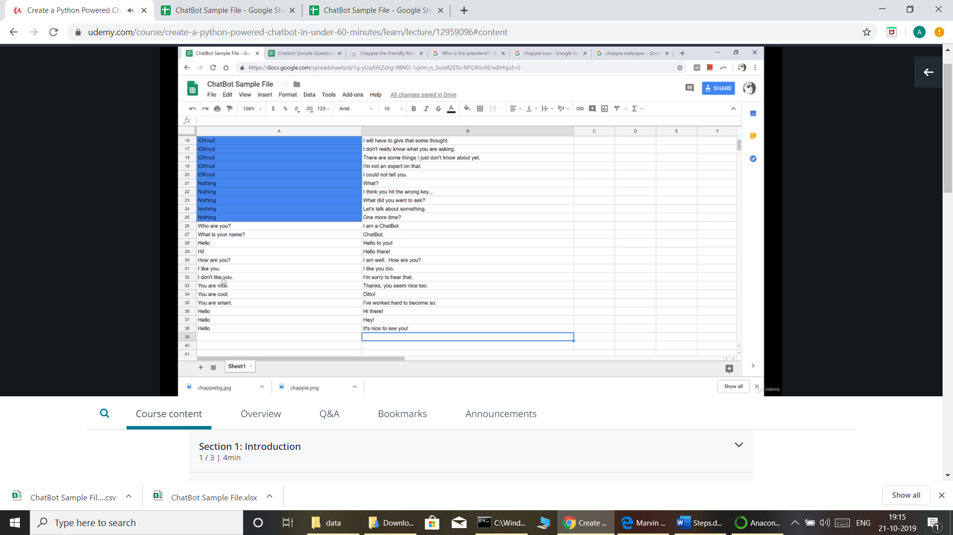

[13] Custom Response for Date ,Time,

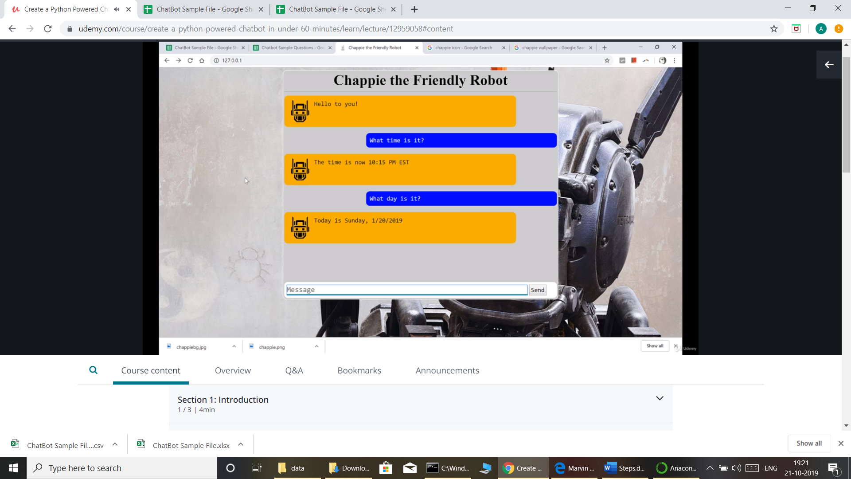

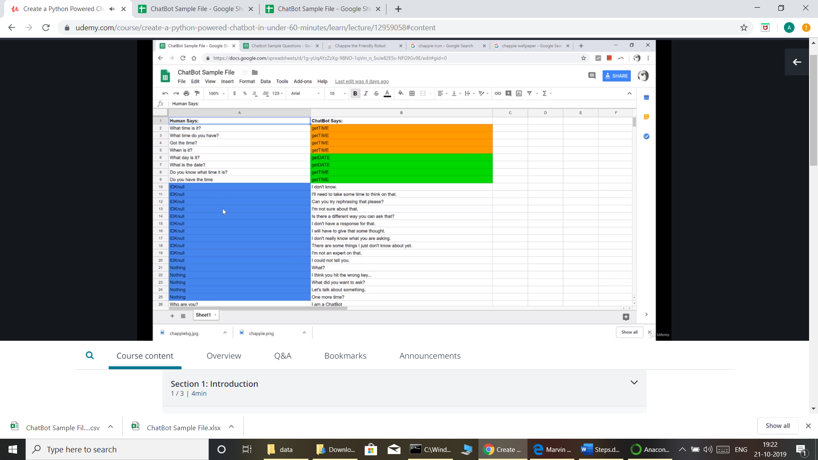

[15]:

Using Google Search If Question not found using ‘BotConfig.py’

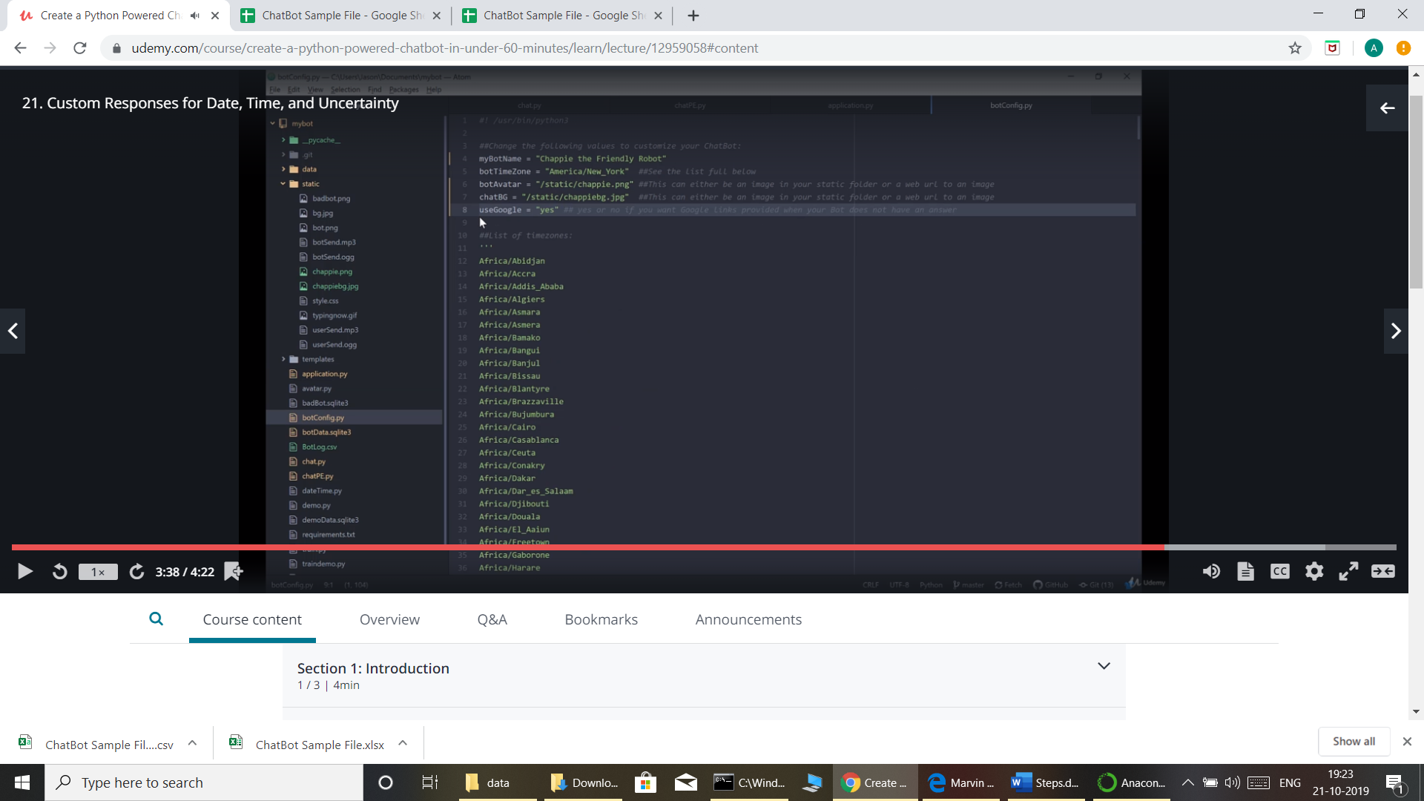

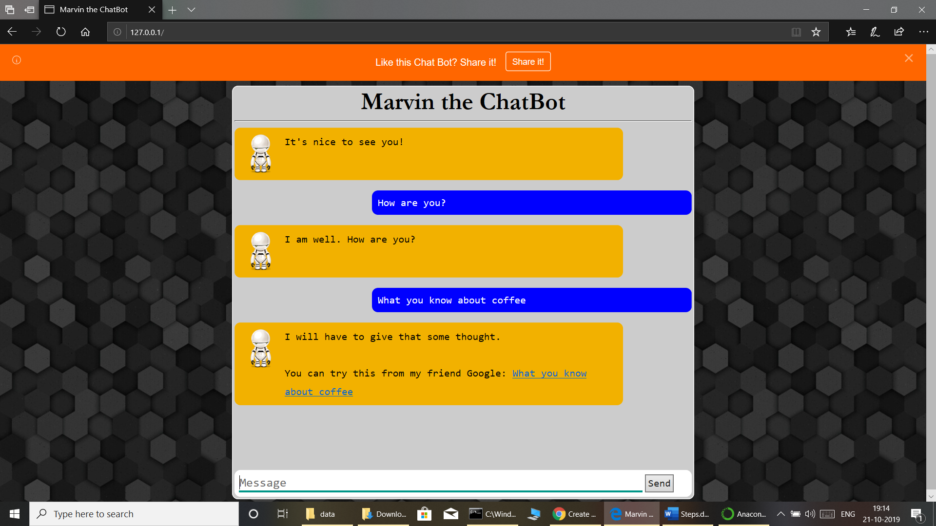

[16]. Advance Responses :

Display Image as a Answer for Question.

<img src=”[https://](NULL)*.jpg”>

<a href=”<http://www.uhg.com>”>Company Website</a>

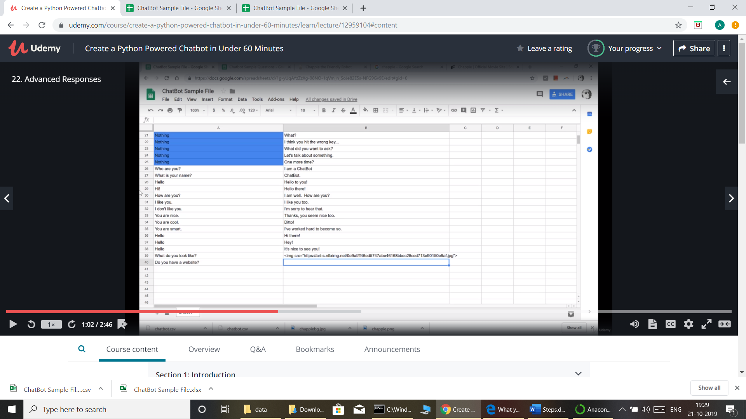

[17]: Learning from Conversation.

#python trainlog.py

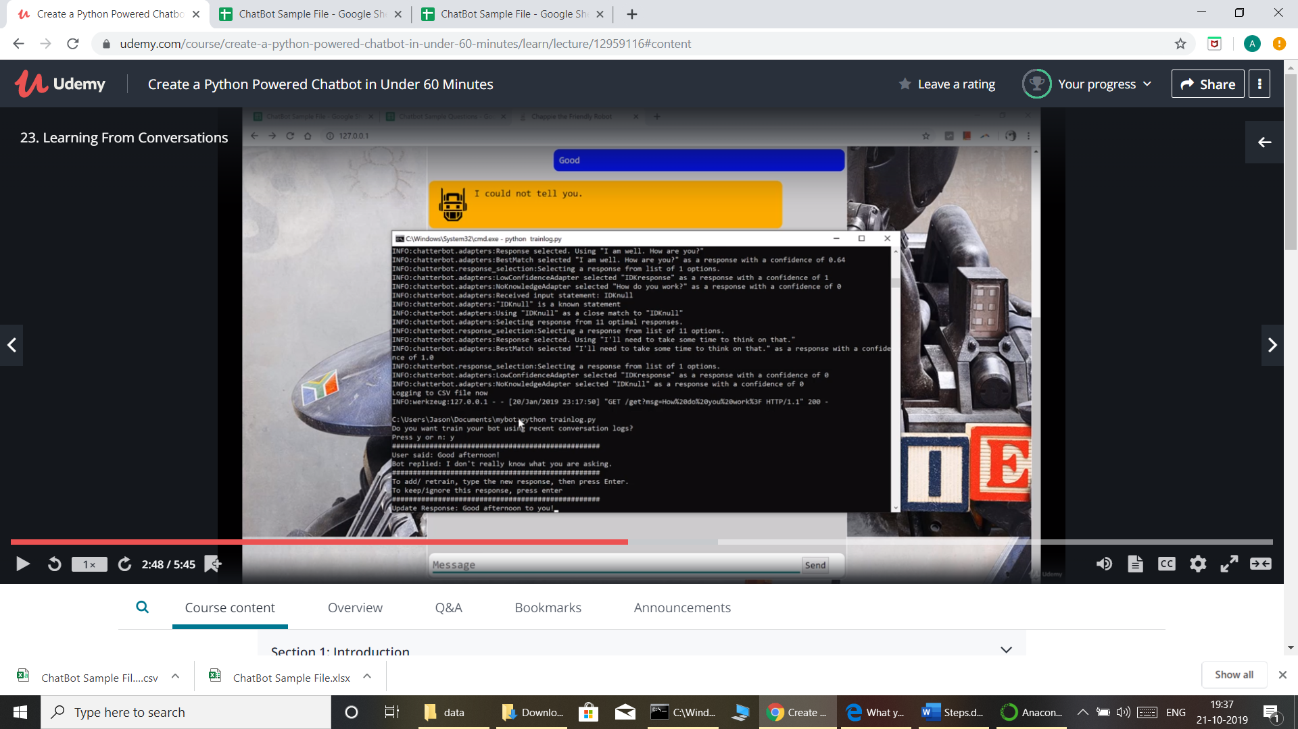

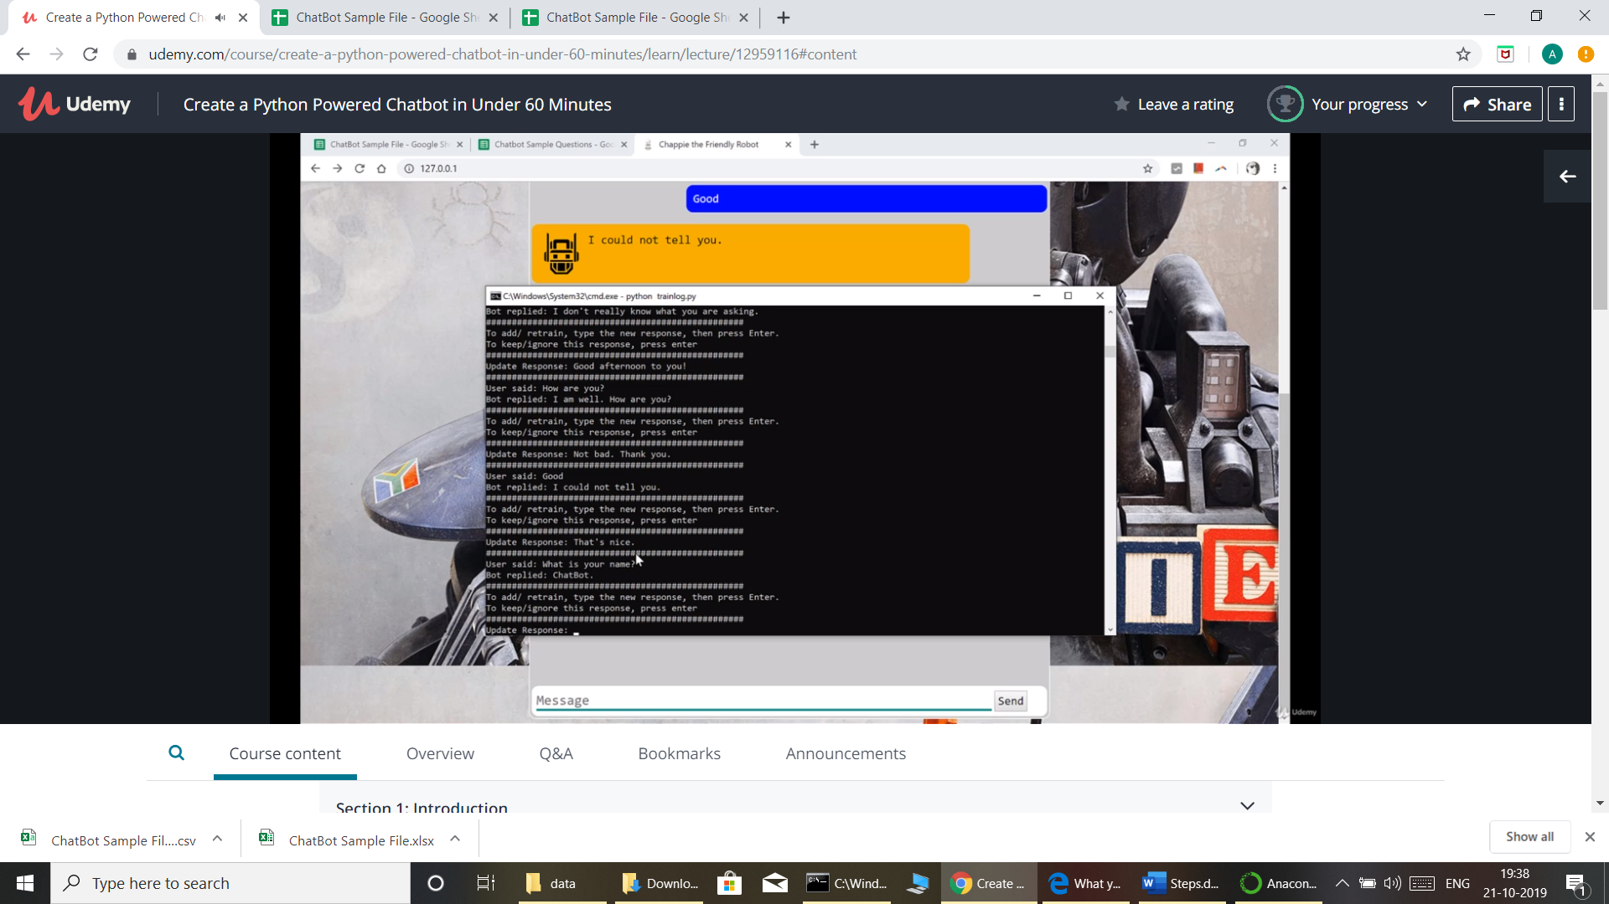

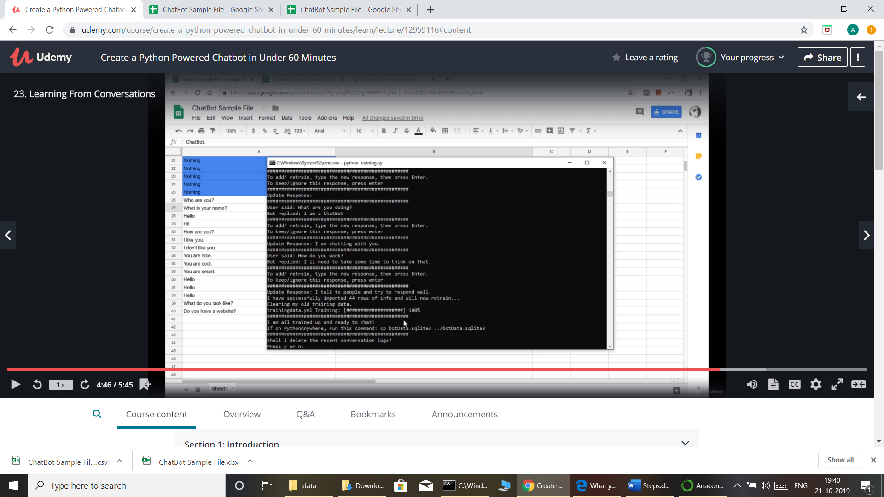

[18] Restart chat server after Learning from Conversation.

#python chat.py

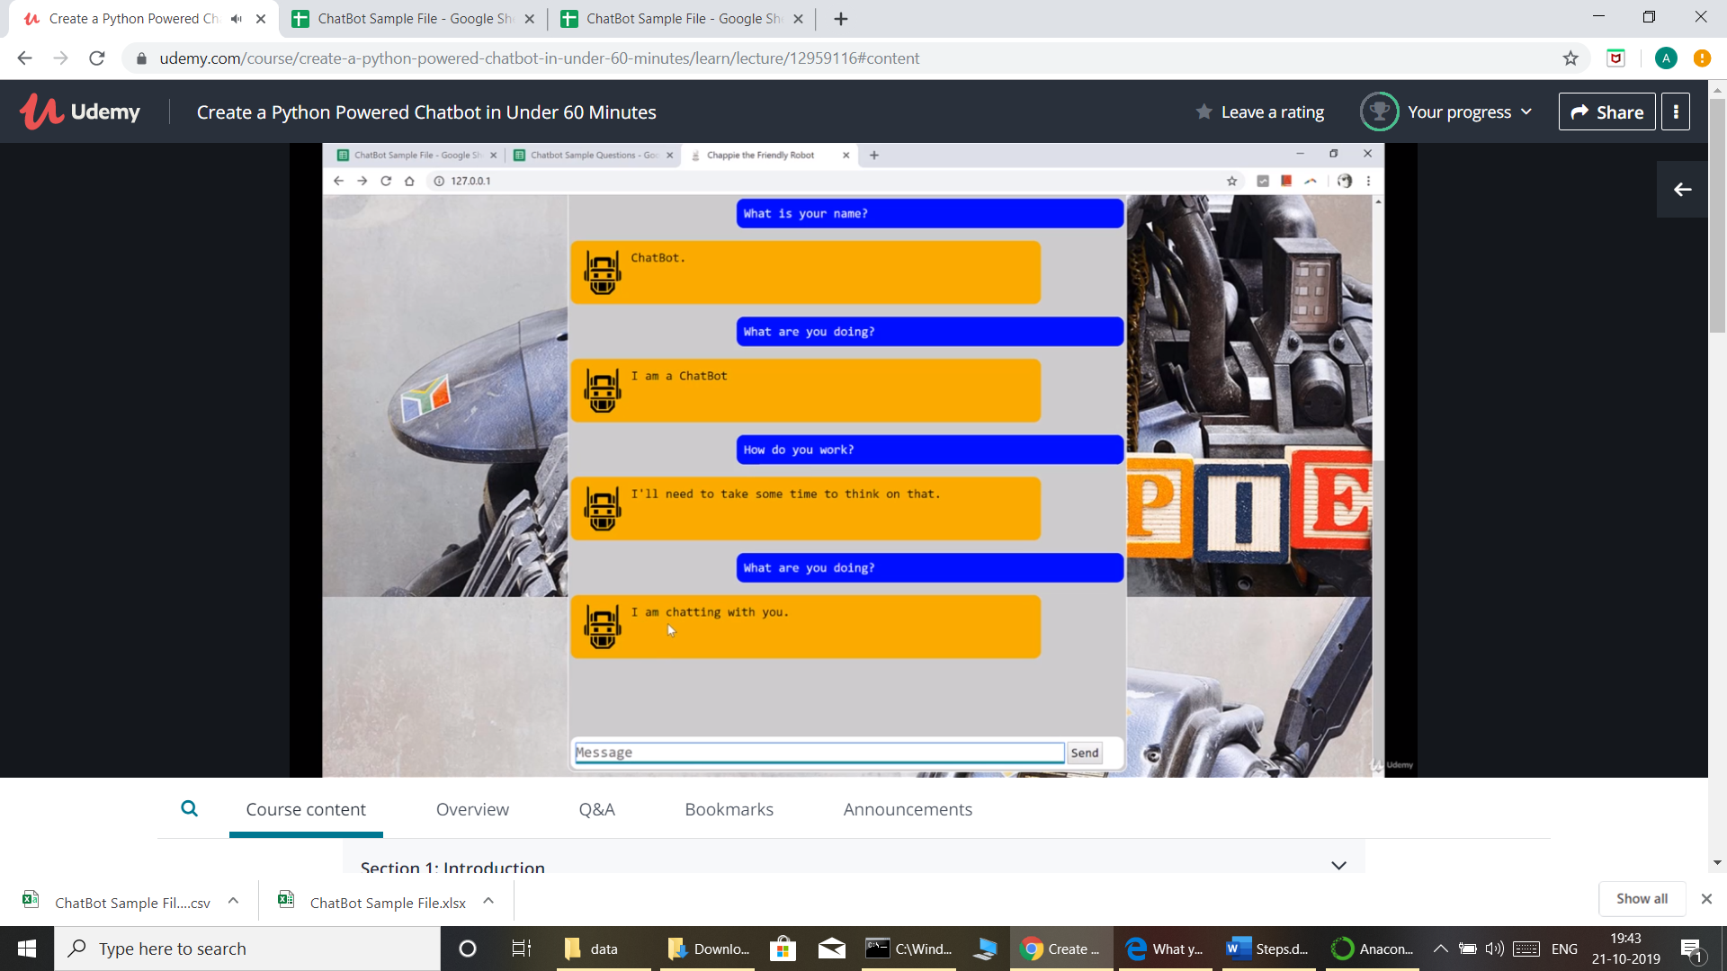

[19]. Backup for bot :

#python trainlog.py

Chapter 24

Update Excel same question type on bot ui. And then run below command.

#python train.py

[20].Customize bot even more.

Style.css

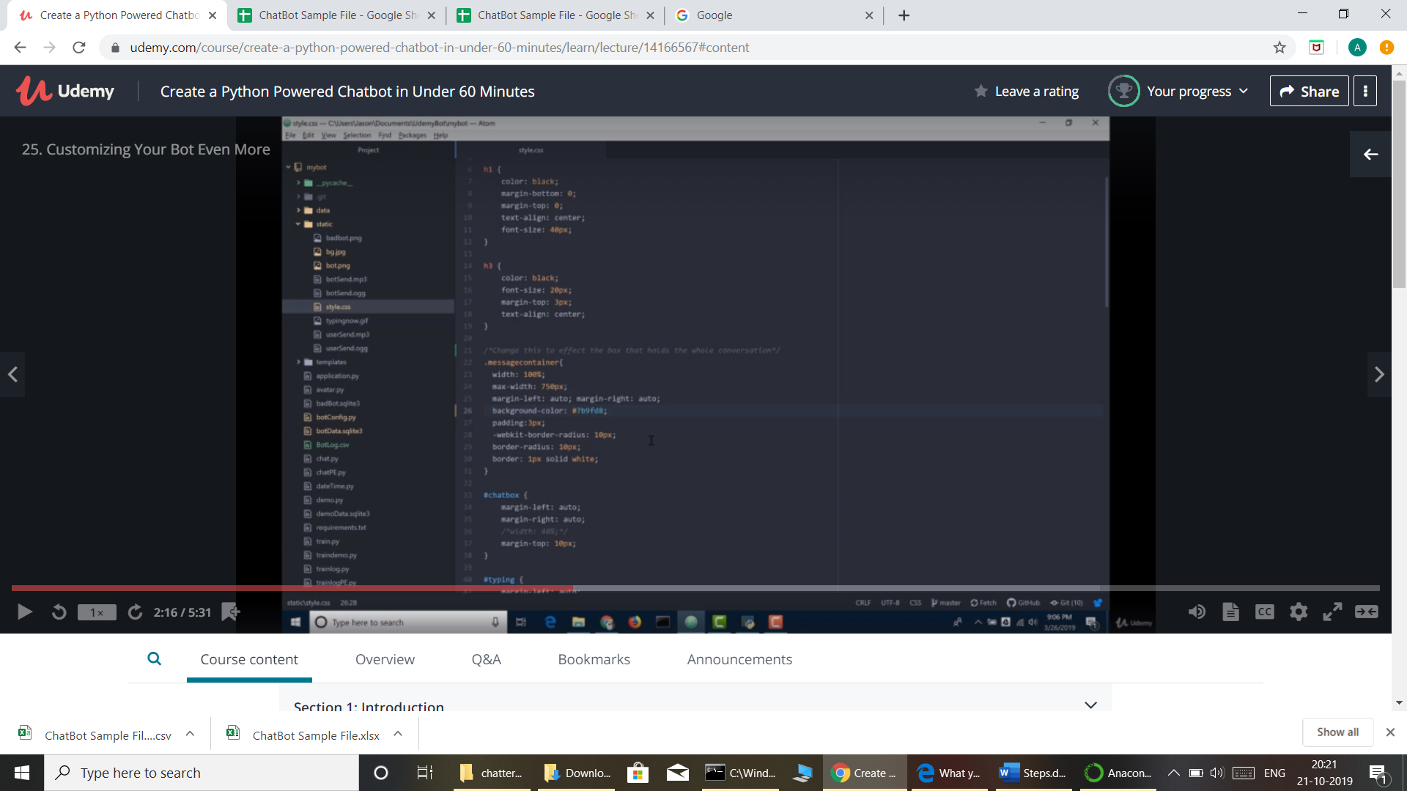

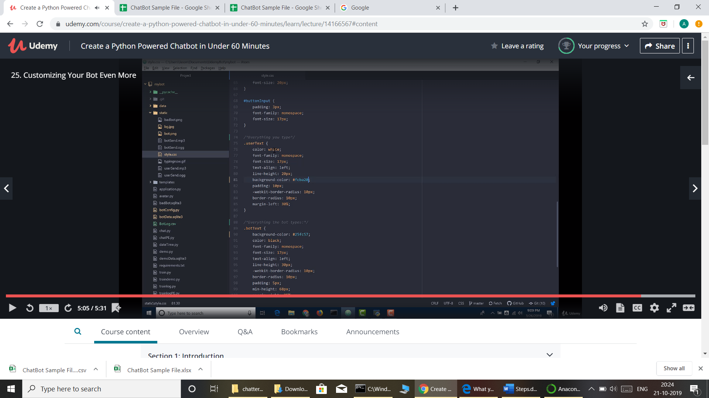

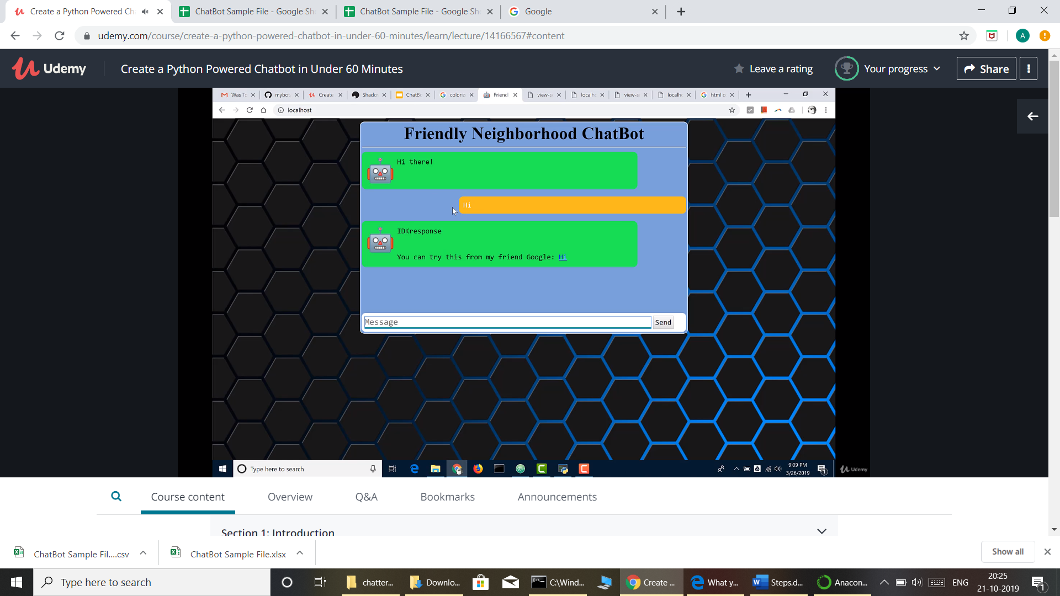

[20]

<https://buildmedia.readthedocs.org/media/pdf/chatterbot/stable/chatterbot.pdf>

<https://github.com/gunthercox/ChatterBot/issues/1062>

[21] Publish chatbot on Internet using <https://pythonanywhere.com>

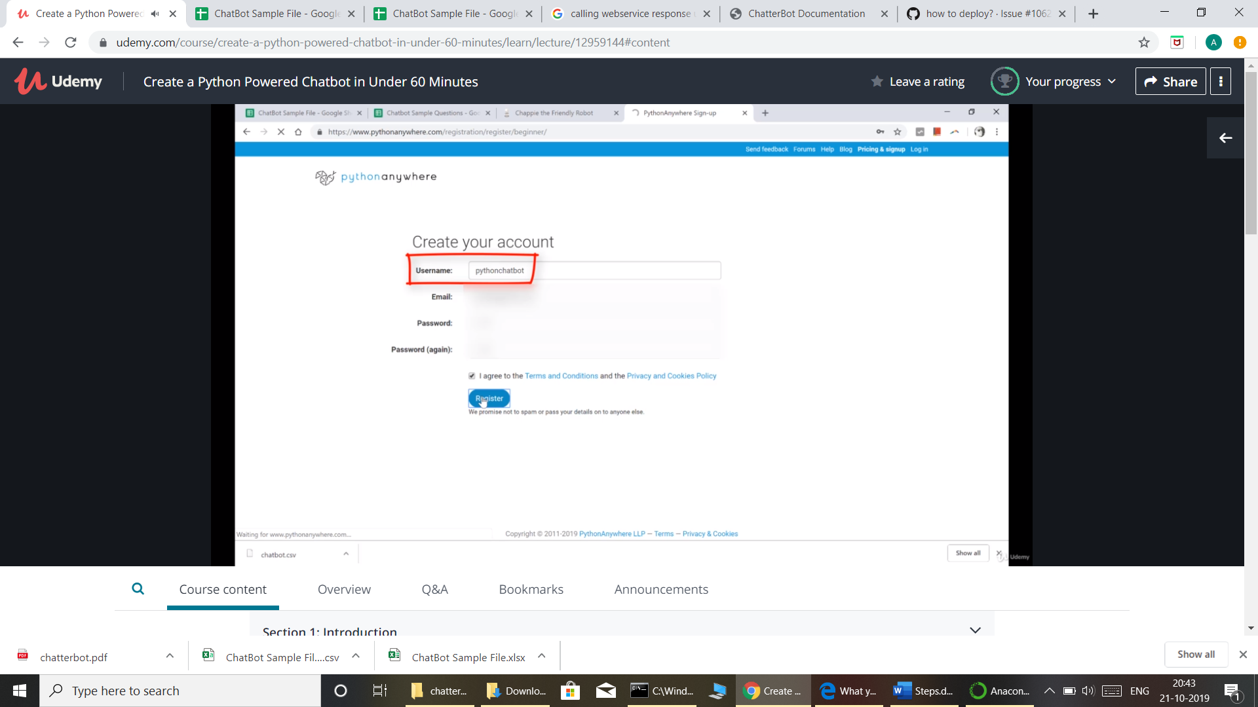

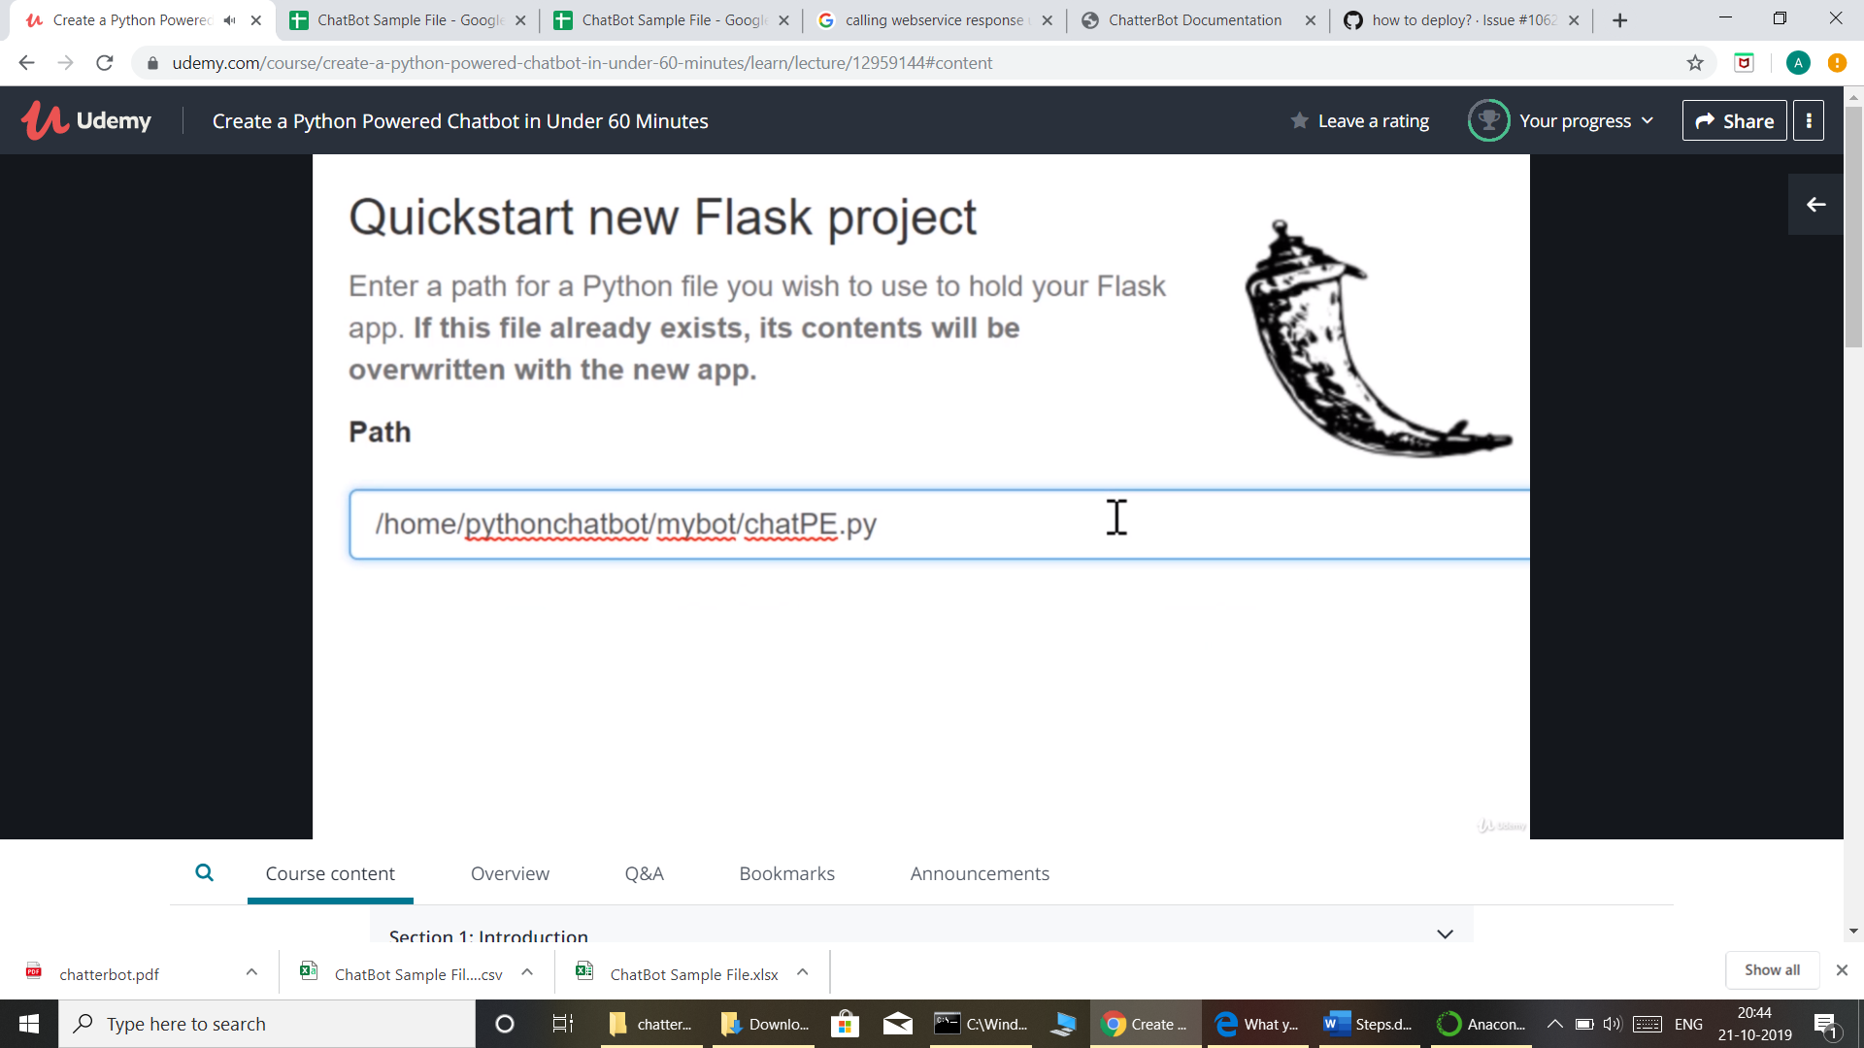

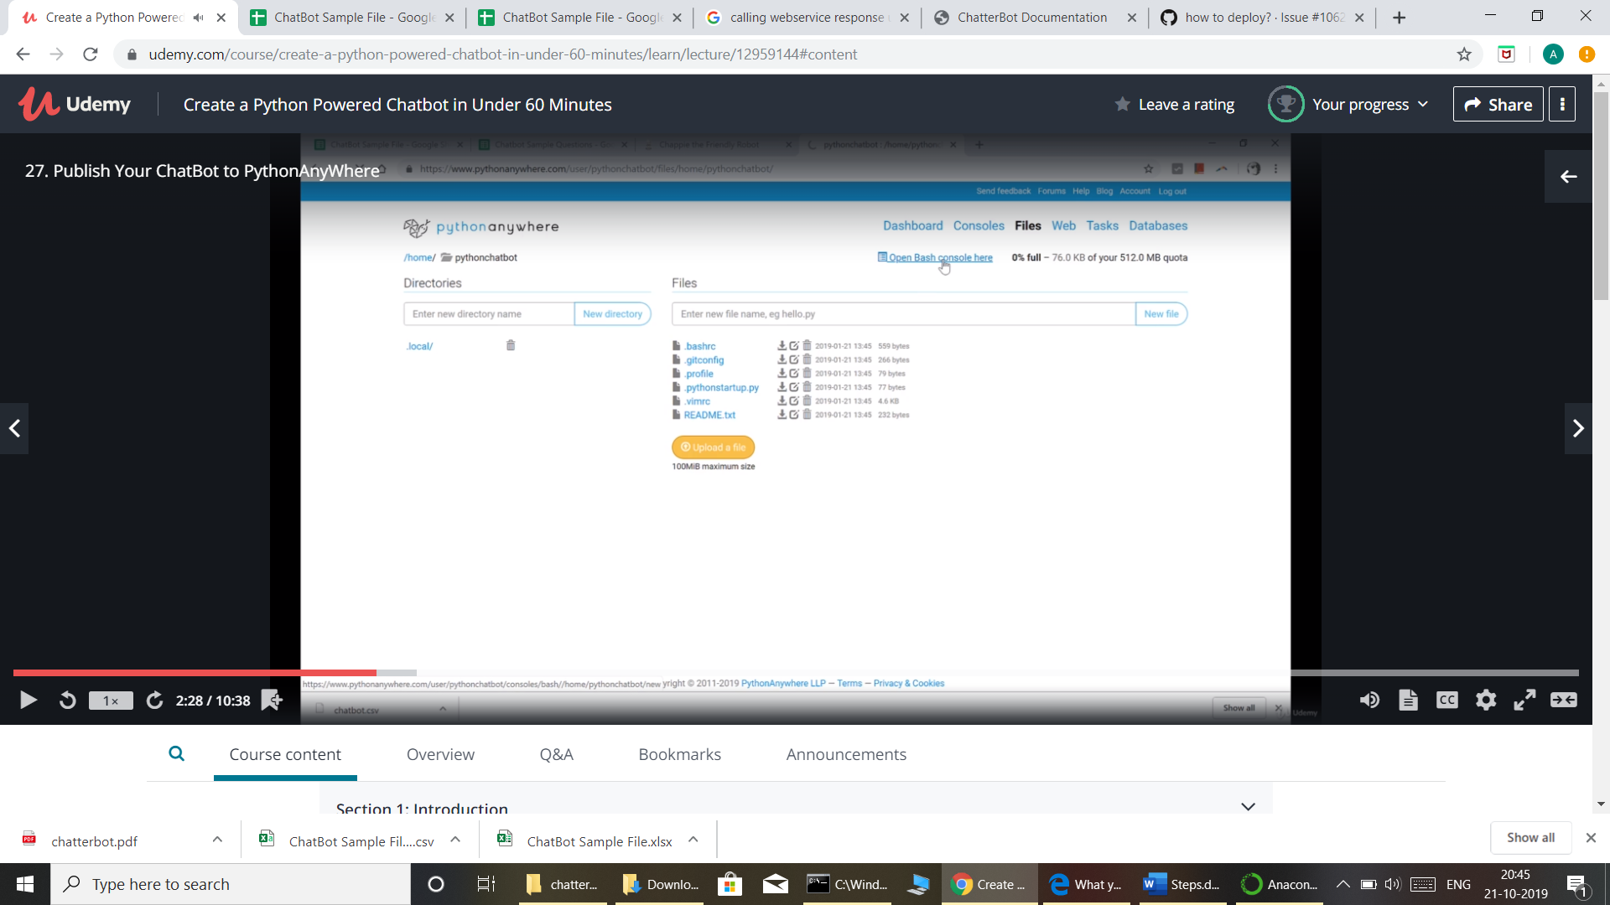

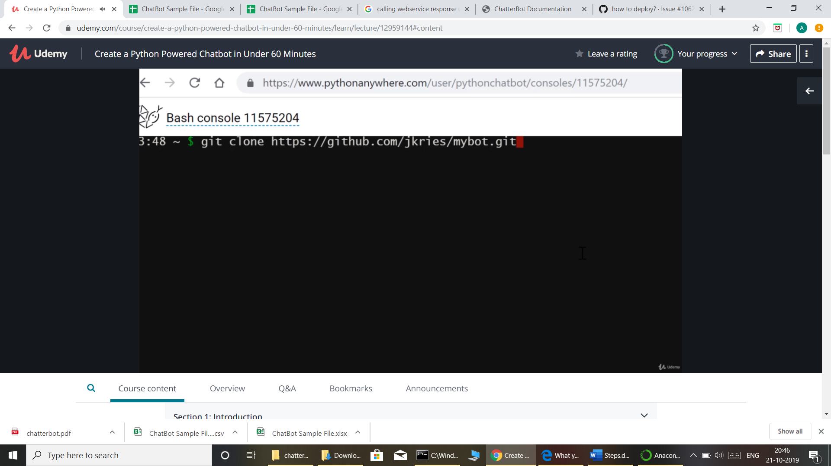

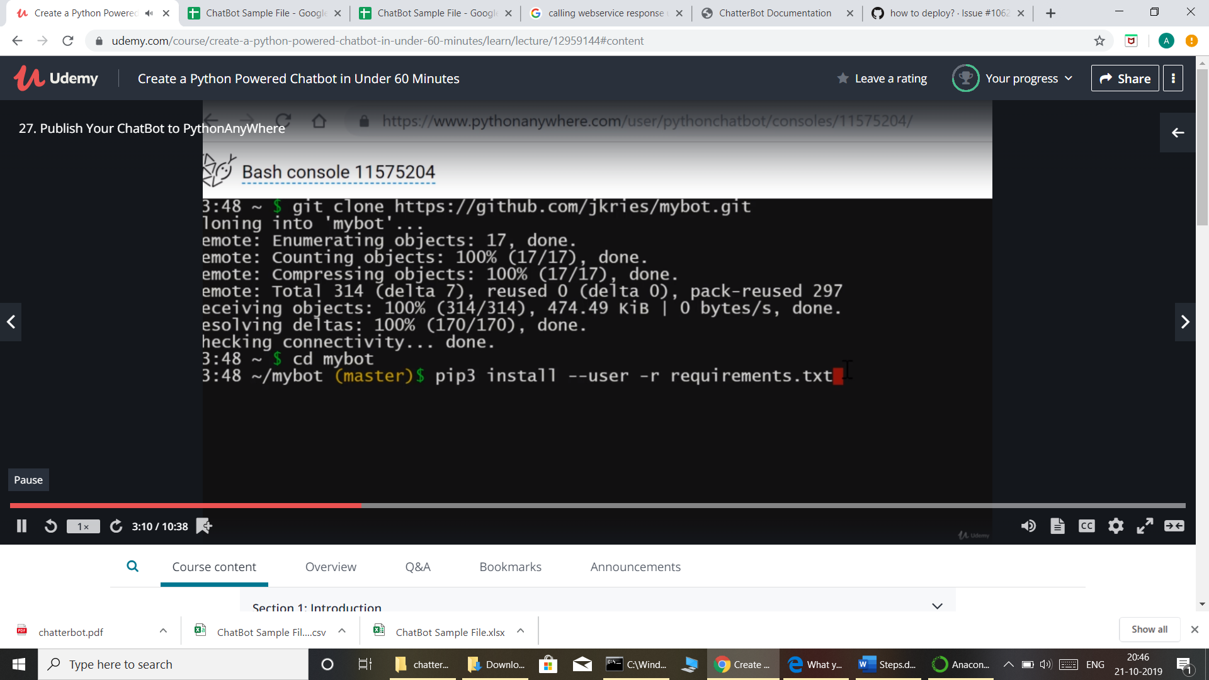

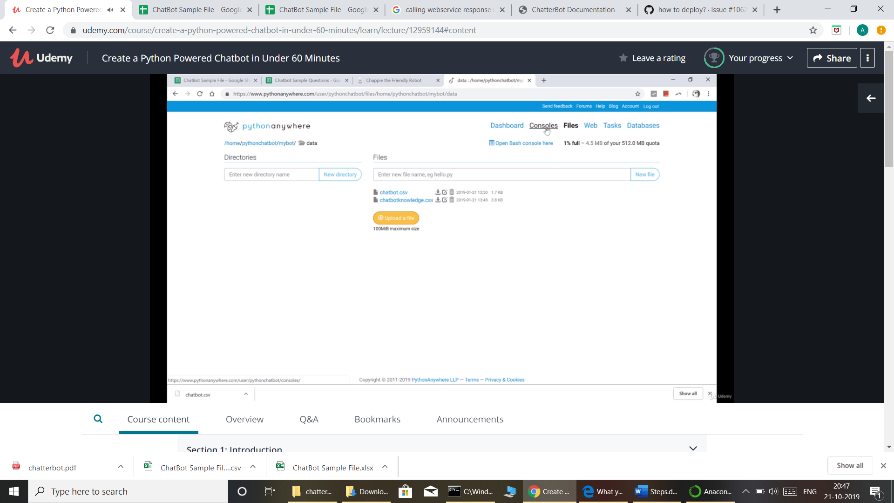

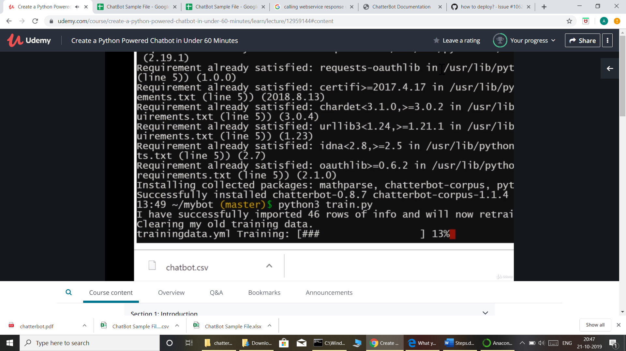

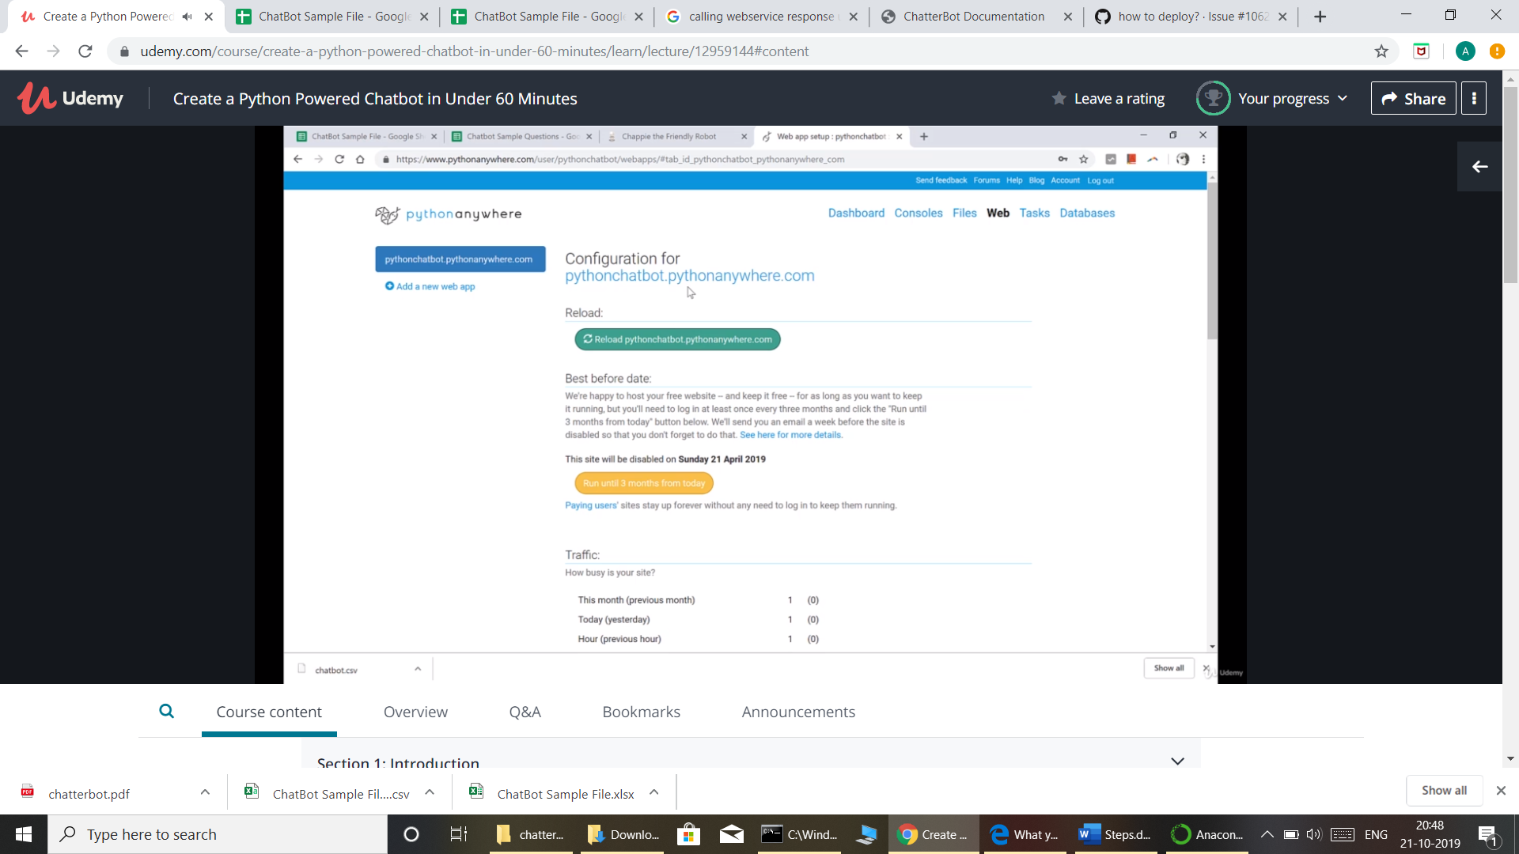

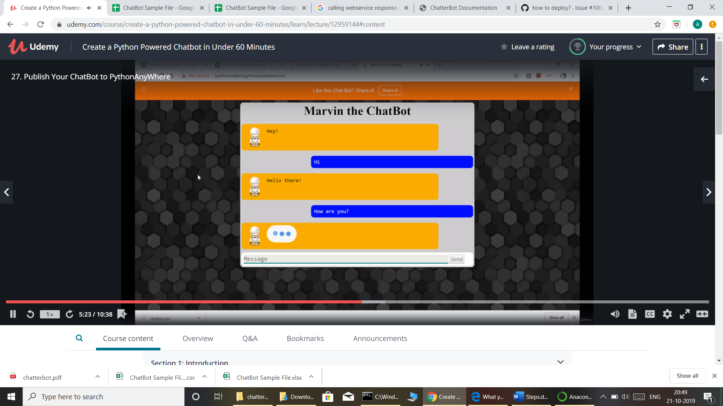

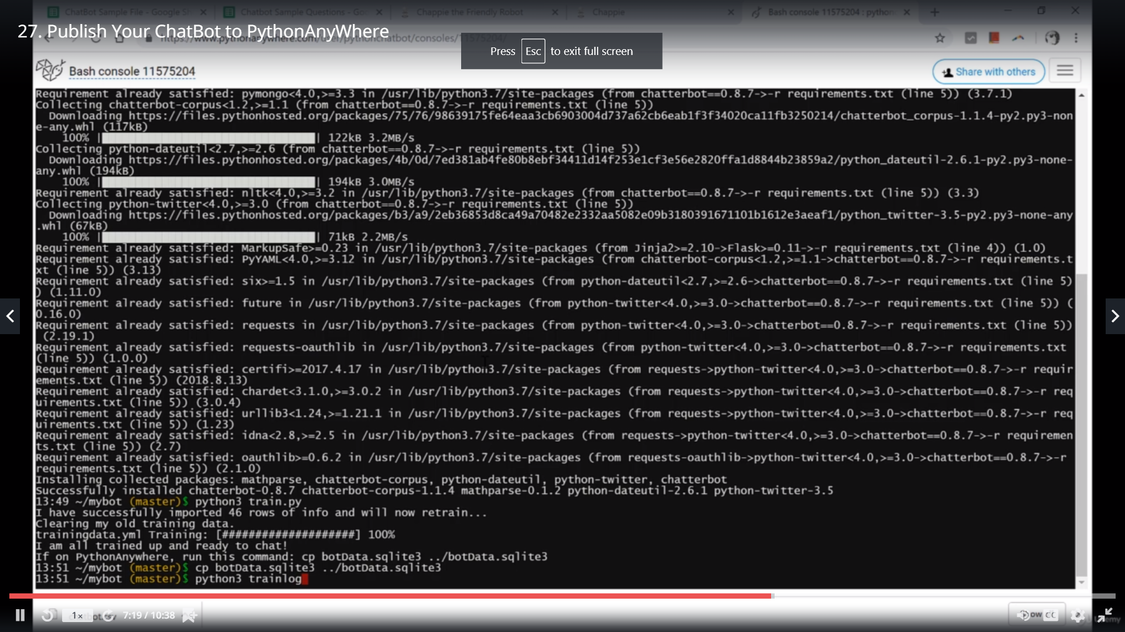

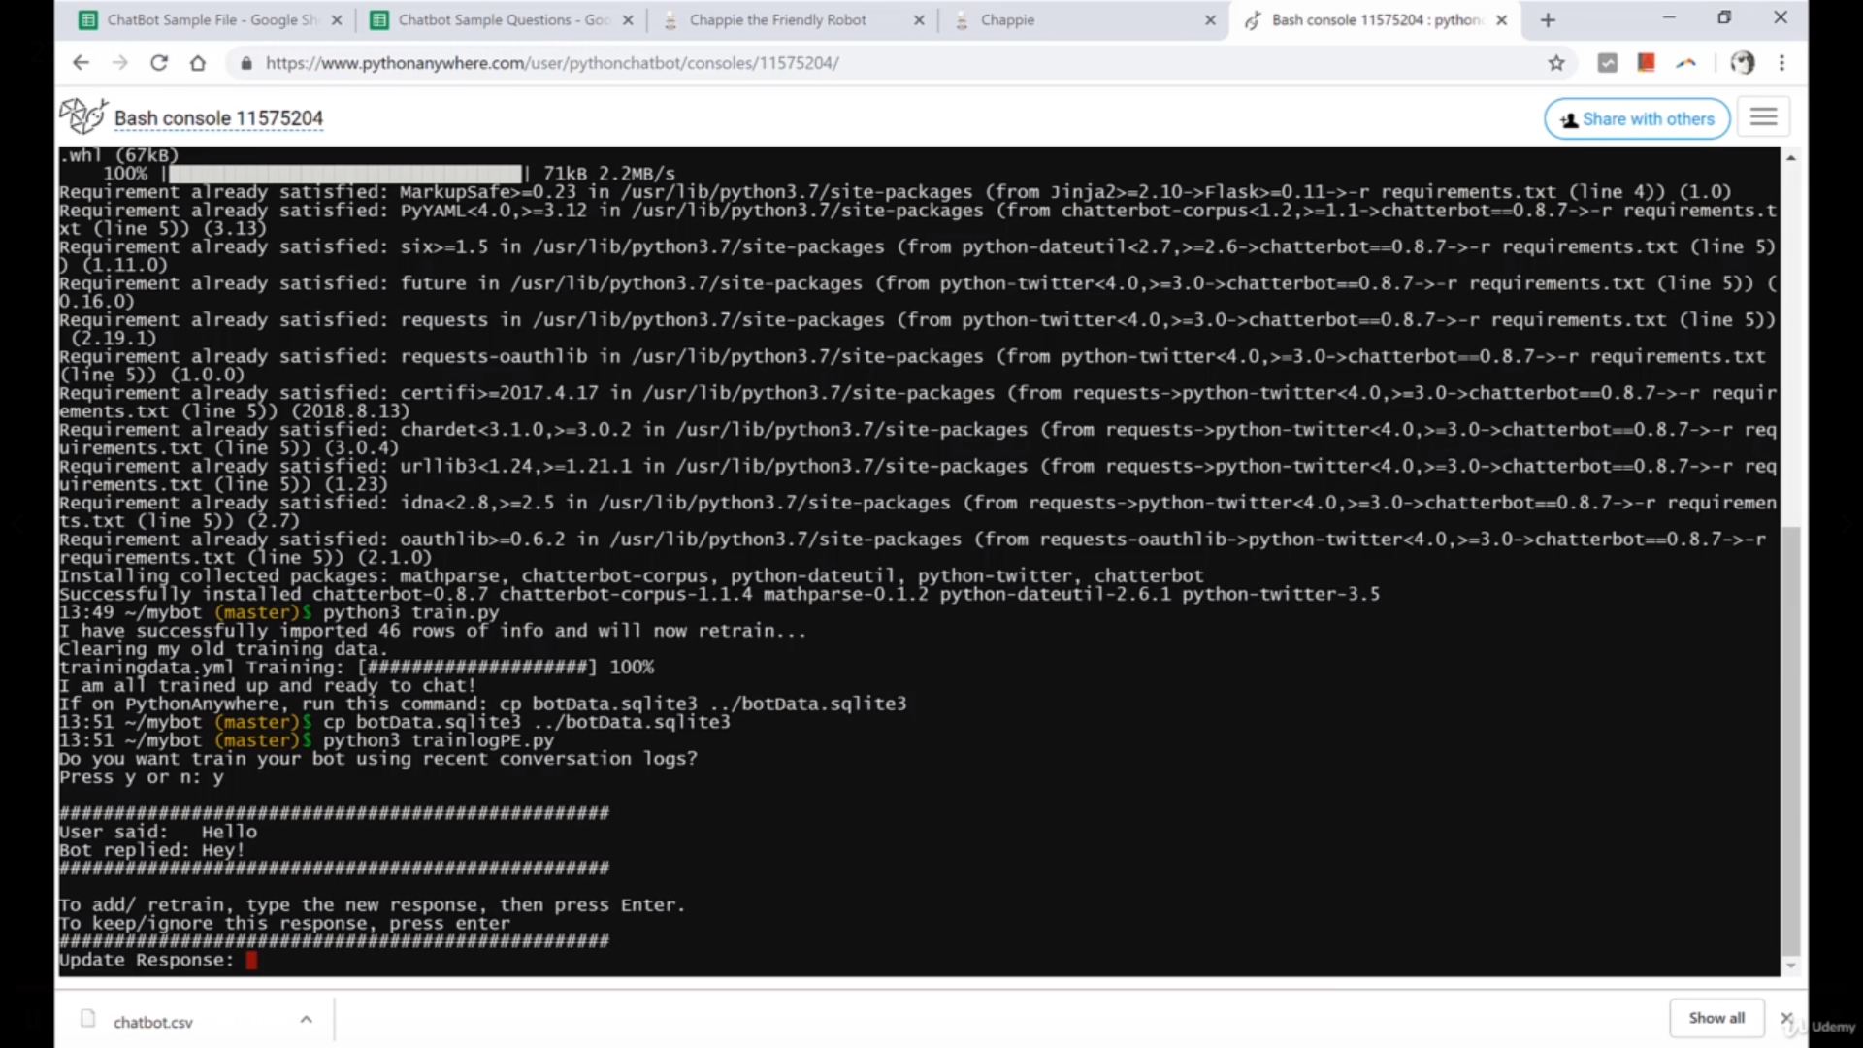

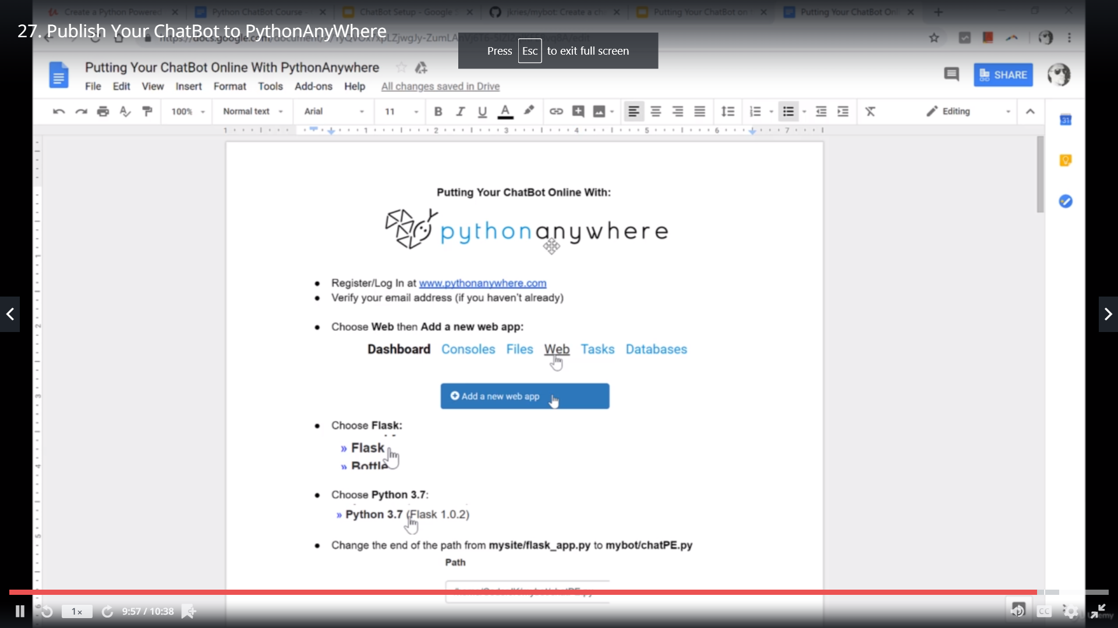

[21]: Add Button to response.

#pip install pyperclip

Add css in ChatSuggest

[22]:Deploy

<https://docs.djangoproject.com/en/1.11/howto/deployment/wsgi/modwsgi/>

<https://chatterbot.readthedocs.io/en/stable/django/wsgi.html#webservices>